  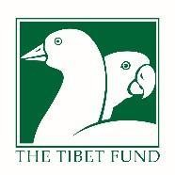

**Program to Strengthen Self Reliance and Resilience of Tibetan Communities in South Asia**

**Quarterly Report April 1 to June 30, 2019**

**Submitted to the U.S. Agency for International Development / India Mission**

**As per Cooperative Agreement AID-386-G-16-00001**

**The Tibet Fund 241 East 32nd Street New York, NY 10016**

**(212) 213-5011**

**CONTENTS**

1. Overview 2
2. Technical Approach 3
3. Key Accomplishments 4

KRA 1: Entrepreneurship, Micro and Small Enterprise Development 4

KRA 2: Workforce Development 10

KRA 3: Agriculture Development 13

KRA 4: Basic Education Strengthening 21

KRA 5: Access to Higher Education 28

KRA 6: Community Health Improvement 30

KRA 7: Participatory Community Development 35

KRA 8: Women Empowerment 41

KRA 9: Institutional Capacity Development 42

KRA 10: Leadership Development 43

KRA 11: Cultural Institution and Resilience Strengthening 45

1. Monitoring, Evaluation, and Learning 51

Annex 1: Summary Performance Data 55

1. **OVERVIEW**

The overall goal of the program is to strengthen the self-reliance and resilience of Tibetan communities in South Asia through sustainable livelihoods improvement and strengthened local institutions. The program employs an integrated multi-sector approach combining strategies to increase household incomes and employment, improve basic education quality, increase access to higher education, and improve community health. Sector strategies are integrated with community-based planning to maximize local participation and ownership of the development process, and a gender component incorporates women’s perspectives and participation in the design and implementation of all strategies. Beneficiary involvement in prioritizing local needs and identifying community-specific solutions is expected to substantially increase the performance, impact, and sustainability of program strategies and initiatives.

In parallel the program aims to strengthen key Tibetan institutions essential to ensuring the continuity of effective program strategies and long-term impact on community self-reliance and resilience. Institution strengthening focuses in particular on the CTA and partner organizations affiliated with the CTA, and a small grants fund focusing on Tibetan arts, language, and culture contributes to cultural preservation and resilience.

The TSRR program is being implemented in two phases over five years. In the first phase, from FY17 Q1 through FY18 Q4, support was provided for high priorities while diagnostic assessments were completed to inform evidence-based planning of phase two road maps and sector strategies. Concurrently with assessments, a revolving loan fund and participatory development planning were introduced on a pilot basis, with the goal of learning lessons that can be scaled up in phase two. Phase II of TSRR commenced in FY19 Q1 and will end in September, 2021.

The Tibet Fund is responsible for overall management and monitoring of the program and works closely with the CTA through sub grants to the Social and Resource Development Fund (SARD) in India and local partner NGOs in Nepal. Program activities are planned, implemented, and monitored using a proven collaborative approach that draws on past experience managing U.S. federal grants in close cooperation with the CTA, and adopts the same financial management and operating mechanisms used to implement the USAID funded Tibet Education Project and Tibetan Health System Capacity Strengthening Project. This approach aims to ensure the program meets high standards of implementation quality and complies with USAID rules and regulations, and at the same time builds CTA capacity to sustain program investments and outcomes.

# TECHNICAL APPROACH

The program has two main components: (I) Sustainable Livelihoods Improvement and (II) Strengthening Tibetan Institutions and Cultural Resilience. Recognizing that income, employment, education, and health are interconnected determinants of sustainable livelihoods improvement and self-reliance, the first component supports an integrated multi-sector approach designed to achieve the following strategic objectives (SO):

* + SO1. Increase household incomes and employment, particularly among unemployed youth, through increased entrepreneurship and small enterprise growth, improved job skills, and increased value of marketable agriculture products
  + SO2. Improve quality of teaching and learning in Tibetan schools and increase access to higher education
  + SO3. Increase access to affordable quality health care and reduce burden of impoverishing disease
  + SO4. Increase participation and ownership of local communities in the development process
  + SO5. Increase participation and empowerment of women in the development process The second program component has the following strategic objectives:
  + SO6. Improve effectiveness, capacity, and sustainability of local institutions serving Tibetan communities
  + SO7. Increase cultural vitality and resilience of Tibetan communities

Strategies to achieve these objectives are being supported in the following Key Result Areas (KRA):

* + KRA1. Entrepreneurship, Micro and Small Enterprise Development (contributing to SO1)
  + KRA2. Workforce Development (contributing to SO1)
  + KRA3. Agriculture Development (contributing to SO1)
  + KRA4. Basic Education Strengthening (contributing to SO2)
  + KRA5. Access to Higher Education (contributing to SO2)
  + KRA6. Community Health Improvement (contributing to SO3)
  + KRA7. Participatory Community Development (contributing to SO1-4)
  + KRA8. Women Empowerment (contributing to SO1-5)
  + KRA9. Institutional Capacity Development (contributing to SO6)
  + KRA10. Leadership Development (contributing to SO6)
  + KRA11. Cultural Institution and Resilience Strengthening (contributing to SO7) Implementation progress in the past quarter is described below.

# KEY ACCOMPLISHMENTS

# KRA 1: ENTREPRENEURSHIP, MICRO AND SMALL ENTERPRISE DEVELOPMENT

* 1. **Tibetan Entrepreneurship Development**

In 2013 the CTA launched the Tibetan Entrepreneurship Development (TED) initiative with seed funding from the U.S. Department of State Bureau of Population, Refugees and Migration (PRM), The Tibet Fund, and private donors. With the inception of TSRR a diagnostic assessment was conducted to provide evidence-based recommendations to inform phase II planning. While the assessment was being conducted in FY17-18, TSRR supported continuation of TED business development services (BDS) for new and aspiring entrepreneurs, piloting of new BDS for existing MSMEs, and piloting of a new skills to enterprise (STE) service model for vocational trainees. Phase II of this program component began in FY19 Q1.

As part of the assessment a road map was developed that outlines a multi-year strategy for the TED initiative in India, with a timetable and notional targets for FY19-FY21. Key recommendations were to shift the focus of TED services toward greater numbers of informal sector microenterprises and MSMEs, versus the low number of new starts ups and “potentially scalable businesses” TED prioritized in the past; to contract service delivery to experienced specialists and focus TED team efforts on program management and coordination rather than direct service delivery; to discontinue TED support for students; and to give the TED team greater autonomy and relocate it outside the CTA Department of Finance office.

In FY19 the program is providing business development services (BDS) to the following target groups: 1) new and aspiring “TED” entrepreneurs with innovative business ideas; 2) existing microenterprises with scope to increase their competitiveness and profitability, including vulnerable informal sector microenterprises; 3) unemployed youth receiving TSRR-supported vocational training, who aspire to start their own business after completing their vocational training; and 4) existing small and medium size enterprises with potential to grow and expand their businesses, that need new sources of investment and financing.

# Activity progress:

* + Ten start-up entrepreneurs in India who received pre-incubation training and won **seed awards** in FY17-18 continued growing their businesses. In the past quarter one entrepreneur running a travel agency in Bylakuppe, Karnataka, received the final installment of his seed funding. 6 entrepreneurs have now received the full amount of seed funding originally awarded and 3 are expected to receive final installments in the next quarter. Beneficiary businesses include an agricultural startup, a travel agency, and two IT related enterprises, a dance studio cum beauty parlor, a health snack manufacturing enterprise, and an e-commerce site.
  + A **new incubation center** was established in Dharamshala where TED staff began organizing on-site pre-incubation training for start-up entrepreneurs as well as “skills to enterprise” business training for vocational skills trainees. Furniture and computer equipment were installed to equip the space, located near the CTA premises.
  + TED began conducting on-site **pre-incubation training** in Dharamshala for a new cohort of 8 entrepreneurs and business partners representing 6 businesses. Following widespread marketing of TED services in Q1-Q3, a total of 16 entrepreneurs applied for the pre-incubation training. The five-week training is being led by a team of TED staff and five external sector experts, including faculty members of the Jindal Center for Social Innovation and Entrepreneurship (JSIE) in Sonipat, Haryana. The TED team had earlier visited JSIE to receive trainer-training and develop the pre-incubation training curriculum with JSIE. The pre-incubation training is designed to help entrepreneurs validate their initial business ideas, develop business plans, and bridge knowledge and resource gaps with information and contacts. The training will culminate with business plan presentations, after which the 6 businesses are expected to receive seed funding of INR 300,000 each.
  + TED completed a year-long program with Micro-Credit Ratings International Limited (M- CRIL) to implement **business development services** for street vendor microenterprises. Experts from M-CRIL conducted a financial planning training and a digital marketing workshop for 20 shopkeepers, restaurant owners and other MSMEs in Dharamshala. The trainings focused on the importance of financial planning, setting investment goals, portfolio building, importance of online marketing, introduction to online platforms, and social media strategies. The experts worked with business owners to create Facebook pages, Instagram and Google business accounts. Two Self Help Groups (SHGs) of 13 women street vendors each, established in FY18 with TSRR support, continued to hold monthly meetings and collaborated on running a fast food stall during a popular local football tournament. SHGs were formed to create social capital among street vendors and act as vehicles for collective action to uplift their overall socio-economic condition.

Similar trainings led by M-CRIL were held in Clementown for 21 MSMEs from the Dehradun region. The experts also made market and vendor stall visits and helped design signboards and menus based on individual needs. A bookkeeping training was also held for nine fast food vendors and restaurant owners in the Dehradun region.

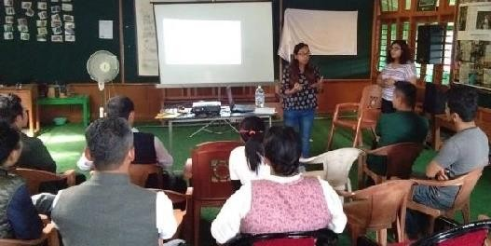

Restaurant and shop owners attending a digital marketing training

TED plans to continue working with MSMEs in Dharamshala and Dehradun to help build individual stall display and merchandising identities, create personalized marketing tools, regularize supplier connections and inventory sourcing, and develop online visibility and marketing.

* + TED organized a business plan competition for vocational skills trainees at the Dharamshala Tibetan Career Center (DTCC). Six trainees participated in the competition and the jury selected three hair dressing trainees to receive seed funding awards ranging from INR 100,000 to INR 300,000 to start and improve salon businesses in Dharamshala and Clementown settlement in Dehradun. The trainees had earlier completed a three- month **skills to enterprise** (STE) program designed and led by Natio Cultus, a strategy consulting and financial advisory firm based in Bangalore. The program focused on products, services and value proposition, business development, marketing, operation and financial management, public speaking, body language, and business pitching. Winners of business plan competitions are expected to receive first installments of seed awards in the next quarter, as they start achieving their milestones.

Two earlier winners of business plan competitions held for vocational skills trainees continued to make progress towards opening their businesses. One of the winners received INR 220,000 after achieving two milestones, and the other is expected to start receiving her seed funding in the next quarter. Both winners plan to open salons in Leh and Mundgod Tibetan settlements.

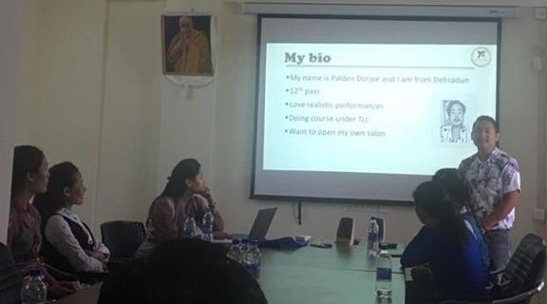

STE trainees taking part in business plan competition

* + TED began working with Natio Cultus to provide **business acceleration services** to SMEs with potential to expand their businesses. TED identified three entrepreneurs associated with their programs – Kera Fashion, Tenzin Kitchen, and a Kollegal based agri-tech enterprise – to benefit from investment readiness consultation and advisory support. An open announcement and selection of two more SMEs are planned in the next quarter. Natio Cultus and TED staff will assist the five SMEs with networking, sourcing investment opportunities, linking business owners with experienced mentors, and preparing investment pitches to raise new financing.
  + Members of **entrepreneur hubs** (E-hubs) established with TSRR support continued to organize activities to bring together business-minded young professionals, MBA students and college students. 19 Tibetan youth participated in a business plan development workshop led by TED staff in Delhi, and 33 students participated in a mock business plan competition at which six students pitched their business plans.
  + In Nepal existing beneficiaries of **entrepreneurship training and seed funding** continued receiving mentorship support from a small business development consultant. Beneficiary businesses include a sportswear retail store, a bakery, two noodle production enterprises, two tailoring shops, a statue manufacturing enterprise, a graphic design business, a mountain bike repair shop, and a dried fruit production enterprise. Four businesses will receive the last round of outstanding FY17-18 seed grant installments in the next quarter.
  + A team of independent consultants completed a **midterm review** of TED activities in Nepal following concerns expressed by beneficiaries and partners over the program’s implementation, management and effectiveness. Findings and recommendations were presented to TTF and SARD staff in Kathmandu in May. Due to inadequacy of the existing approach, which has reached few beneficiaries with poor results, and differences among partners on the technical and operational way forward, new TED activities in Nepal were suspended indefinitely, with the exception of continuing mentoring support for past beneficiaries.

# Access to Enterprise Finance

To address the critical need of Tibetan enterprises for start-up and expansion capital, the program is supporting establishment of a new local financial institution India, a Non-Banking Financial Company (NBFC). Over time it is expected the NBFC will qualify for conversion to a Small Finance Bank that can provide a sustainable source of savings and loan services to Tibetan businesses as well as earn revenue for the Central Tibetan Administration (CTA). In FY17 the process of registering and setting up the NBFC began, an enterprise finance team was recruited and a chartered accounting firm was hired to provide technical expertise and assist with NBFC registration. In parallel, a pilot revolving loan fund was launched to provide loans to seasonal garment vendors, and in FY18 new loan products were piloted for other target groups.

In Nepal, SARD and TTF researched options to provide Tibetan enterprises with access to small loans and a plan was formed with the goal of community borrower groups managing their own loan and savings funds independently. Key elements of the plan include eligibility for all community members, loan amounts ranging from NPR 75,000 to 200,000, an annual interest rate of 4%, quarterly repayment installments, and formation of borrower groups that guarantee repayment of all group members. Community-managed revolving fund (CMRF) loans were disbursed in five pilot settlements in Pokhara in FY19, and in FY20 a savings component will be introduced in the same settlements. Based on pilot lessons, credit and savings will be introduced in additional settlements of Nepal in FY20-21. A team of technical experts with extensive experience in microfinance, credit management, and IT is assisting in establishing a robust loan management and monitoring system and building the capacity of settlement offices, borrower groups, and Lodrik Welfare Fund (LWF), the local NGO partner.

# Activity progress:

* + SARD continued working with chartered accountancy firm V. Nagarajan & Company (VNC) to create a **special purpose vehicle** (SPV) to transfer existing loan portfolios from SARD to the newly registered and licensed NBFC, Gangjong Development Finance Pvt. Ltd. (GJDF). In the past quarter, a charitable institution, the CTA Development Foundation, was created and successfully registered under the Indian Trust Act of 1882. An income tax exemption application for the Foundation was submitted and work on developing other legal documents continued. Following registration of the SPV as a trust with 12 A and 80 G status, existing loan portfolios in SARD-controlled accounts will be transferred first to the trust, and then over the course of time to GJDF. VNC will provide advisory and handholding services to create the appropriate legal structures to channel investments from SARD to GJDF; develop banking, accounting and reconciliation procedures; develop product development and operational procedures; and build books of account and audit- ready financial statements. Once fully operational, GJDF aims to use best practices to serve Tibetan financial needs before scaling up as a Small Finance Bank. Its stated objectives are to foster economic development, increase employment, diversify the

economic base of the community, mitigate financial exclusion, and promote economic self-sufficiency of Tibetans in India.

* + SARD began implementing the third cycle of RLF lending to **winter garment vendors** to purchase inventory for the coming winter business season. Six-month loans of INR 200,000 were disbursed to 87 winter garment vendors, and an estimated 803 are expected to receive loans in the next quarter. The NBFC team repeated the same process of loan application, selection, loan processing and disbursement practiced in FY17 and FY18, and continued to work closely with the Tibetan Refugee Traders Association (TRTA).
  + Repayment began of loans made in Q2 to 124 **handicraft vendors** and 103 **summer garment vendors** in Ladakh and Dharamshala, while repayment continued of loans made earlier to 25 **trekking horse guides** in Ladakh. Full repayment of all 252 loans is expected by end of the next quarter.
  + Repayment of **commercial vehicle loans** made in FY18 continued. NBFC vehicle loans, which are not directly funded by TSRR, offer credit of up to INR 600,000 for 3 years at 4% annual interest. Only one borrower defaulted on the first repayment installment.
  + **Emergency zero interest loans** were made to 14 Tibetan shopkeepers in Itanagar, the capital city of Arunachal Pradesh, after their shops were gutted following a prolonged regional disturbance. Six-month loans of INR 200,000 at zero interest were intended to provide emergency relief to victims and their families.
  + The GJDF board of directors held its ninth meeting to discuss and pass resolutions on the next **action plan**. SARD also announced a tour of Tibetan communities in North America to **raise capital** for GJDF, for which brochures were designed.
  + In Nepal, announcements of a second round of **community managed revolving fund** (CMRF) loans were made in five Pokhara settlements. Social mobilizers (SMs) facilitated completion of loan application forms and assisted applicants with clarifications about loan terms. Following submission of application forms, loan applicants were interviewed by settlement loan committees (SLC), and borrower groups discussed new applications during their monthly meetings. Utilizing the amounts collected from first repayment installments, nine new borrowers received loans of between NPR 100,000-200,000. Most beneficiary borrowers are involved in souvenir and restaurant businesses and use their loans to increase inventory and purchase small equipment.

Monthly borrower group meetings were facilitated by SMs in all five Pokhara settlements where CMRFs are being implemented. Basic record keeping systems were introduced to borrowers, updates on businesses were shared, and reminders were given on the first loan repayment date.

* + Five social mobilizers received their second training in Pokhara. Conducted by CMRF consultants, the four-day training was designed based on social mobilizer inputs and focused on challenges and areas where the SMs requested additional support. Consultants also provided training on basic financial literacy and life skills for SMs to share with community members during their monthly borrower group meetings. The training also included a field exposure visit to a well-established microfinance project in Pokhara.
  + A second MIS training was held in Kathmandu at the request of accountants from Pokhara settlements. The three-day training was a step-by-step review at which accountants were able to clarify concerns and resolve technical issues with the MIS consultant.

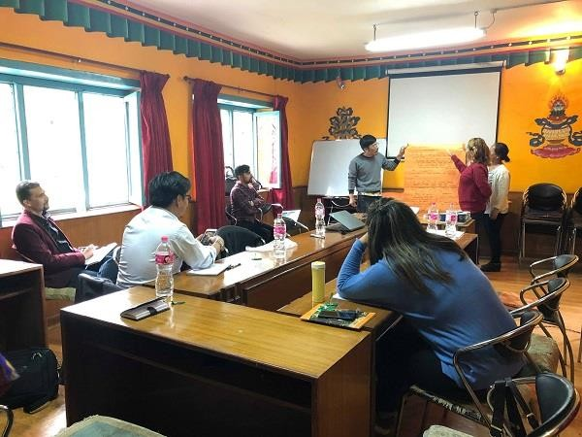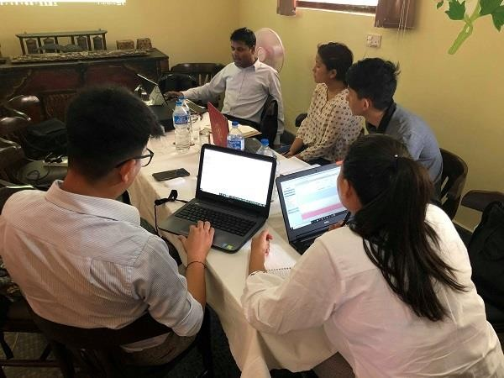

Social mobilizer training in Pokhara (left) and MIS training for accountants in Kathmandu (right)

To ensure this component of TSRR is legal under the host country’s savings and credit regulations and to maximize its impact and sustainability by following sound development practice, CMRF funds will be the sole entitlement of recipient settlement communities, and be utilized solely for the purpose of community-managed savings and loan funds within each respective community. The goal of CMRFs is for revolving fund management capacity to be built at the community level in each settlement, and for each settlement community to become empowered to manage its own CMRF independently, self- sufficiently, and with long-term sustainability.

# KRA 2: WORKFORCE DEVELOPMENT

In 2012 the Dharamshala Tibetan Career Center (DTCC) was established with USAID funding to increase job competitiveness and employment. DTCC delivers vocational skills training, career counseling and job placement services. With the inception of TSRR a diagnostic assessment was conducted to provide evidence-based recommendations to inform phase II planning for KRA 2. While the assessment was being conducted in FY17-18, TSRR supported continuation of existing services at both centers. Phase II of this program component began in FY19.

As part of the assessment a road map was developed that outlines a multi-year strategy for KRA

2 in India with a timetable of key activities and notional targets for FY19-FY21. Key

recommendations were to consolidate vocational training services; collaborate with other training institutions and private sector partners; and formulate a comprehensive CTA workforce development policy. The program is also supporting development of a workforce information system (WFIS) to maintain data on the Tibetan population in all settlements including information on current employment status, age, gender, academic and professional qualifications, and career aspirations.

# Activity progress:

* Short-term training courses, career counseling, and related workshops at DTCC benefitted a number of unemployed youths in the past quarter, as described below.
  + Five trainees completed a three-month **hairdressing course** at DTCC. The course includes daily practice cutting and styling hair and theoretical training on hair anatomy, hair treatment, and hair spa and massage. The trainees also received skills- to-enterprise business training and two trainees won seed funding at the completion of the training. The course is affiliated with the Jawed Habib Foundation, which feeds trainees into its franchise of 184 unisex salons across 62 Indian cities.

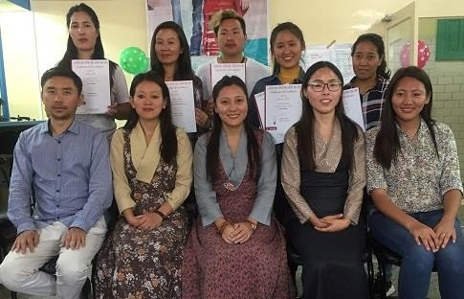

Hairdressing trainees and DTCC staff upon training completion

* + Two trainees concluded and three trainees began a four-month **web design training** at DTCC. The certified course includes practice on indexing, Hypertext Markup Language 5, cascading style sheet, JavaScript, Dreamweaver and WordPress theme development.
  + Eight trainees completed a one-month **Tally accounting software training** at DTCC affiliated with Education Arena Institute. The training focused on basic accounting, fundamentals of Tally, inventory, voucher entry, and generating reports.
  + Ten trainees completed a one-month **Photoshop training** at DTCC, and 26 trainees completed an introductory course in **basic computer skills**. Both trainings were led by experienced Tibetan trainers.
  + Successful professionals and entrepreneurs were invited to share their personal stories and inspire trainees as part of the center’s ‘Saturday food for soul’ event. In the past quarter a successful tattoo artist, a yoga instructor and a former DTCC trainee currently running a salon business in Dharamshala were invited to speak about their life journeys. The speakers stressed the importance of discipline, networking, patience and dedication for achieving success.
  + 22 school and college graduates benefitted from **individual counseling and consultation** services provided by career counselors at DTCC. The counselors gave guidance on employability assistance, course opportunities, career counseling and services, and placement offers via email, Facebook, phone and walk-in visits.
* DTCC career counselors visited Tibetan settlements and schools in Ladakh and Bir settlements where they conducted outreach events and a **career awareness program** attended by more than 450 students and community members. The purpose was to increase awareness of DTCC services including vocational courses, career counseling, job placement, and parental counseling.
* Eleven managers and program officers from six vocational training institutes in India and Nepal took part in a week-long **capacity building** training at the National Institute for Micro, Small and Medium Enterprise (NI-MSME) in Hyderabad. Key topics of the training focused on sector specific skills training curriculum development, counselling techniques to promote self-employment, handholding trainees for effective career path, developing linkages and effective networking, team building, conducting job fairs, and documenting success stories. The training program also included exposure visits to local training institutes and industries. Trainees included managers and staff from DOH’s YES section, DTCC, Norbulingka Institute, Tibetan Homes Foundation in Mussoorie, ITI in Selakui, Envision in Delhi, and SOS in Nepal. The training also acted as a forum for participants to share their experience and discuss ways to provide better skills, education services and employment opportunities to young Tibetans.

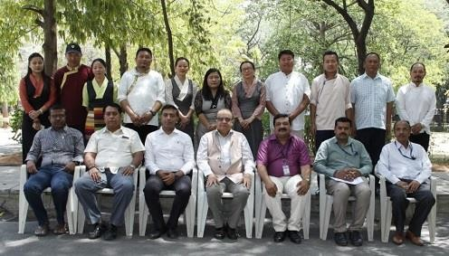

Capacity building training at the National Institute for Micro, Small and Medium Enterprise

* Work continued to build a **workforce information system** (WFIS) database to maintain standard data on the Tibetan workforce in India and Nepal, including current employment status, age, gender, academic and professional qualifications, and career aspirations. Verification continued of data recorded and entered in Tibetan settlement residents over the past year, and circulars were sent to all settlement offices advising staff to register community members who were left out of the initial survey. Customization of data entry formats for data collected from Tibetans living outside South Asia also began.
* The WFIS team gave presentations to TTF and senior DOH and SARD officials on the status of WFIS data entry and analysis, and to a USAID delegation during the course of a TSRR data quality assessment (DQA). The DQA found that the survey method used for the program’s key impact indicator, household income, was technically flawed and recommended further analysis of the data by a third party. TTF plans to engage a specialist to review the data and take steps to ensure future data collection and analysis methods for this indicator are technically sound.

# KRA 3: AGRICULTURE DEVELOPMENT

With the inception of TSRR a diagnostic assessment was conducted to provide evidence-based recommendations to inform phase II of KRA 3. Key assessment recommendations were to shift Tibetan agriculture from household farming to agribusiness; shift from low-tech small holdings to high-tech large holdings; and introduce a new overarching initiative with multiple immediate and long-term interventions, the Tibetan Agriculture Transformation Project (TATP). While the assessment was being conducted in FY17-18, TSRR supported immediate priorities while laying the ground work for TATP. This included introduction of ICT extension services, soil health testing, and KVK demonstration units; development of the Organic Research and Training Center in Bylakuppe; establishment of new regional agriculture extension centers in Chandragiri, Mundgod, and Miao settlements; and cash crop value addition and marketing in other target settlements of India and Nepal. As part of the assessment a road map was developed that outlines a multi-year strategy with a timetable of key activities and notional targets for FY19- FY21. Phase II of this program component began in FY19.

The overarching vision of TATP is to transform the existing agricultural system with a series of well-informed sustainable technical and administrative interventions that will not only increase farmer income but also potentially generate revenue for CTA. Major policy decisions to transform existing low-technology small-holding agriculture to high-tech collective-large-holding mechanized agriculture and remodeling Tibetan agriculture from farm production to agribusiness model will be considered with the help of technical expertise. However, it is beyond the scope and budget of TSRR to implement the entire vision of TATP, which would require multi-million- dollar investments. Due to the program’s budget constraints and competing multi-sectoral priorities, only a few of the assessment-recommended TATP activities will be implemented.

It is envisioned that ORTC in Bylakuppe will become the operational node and driving force of TATP. Many of the recommended interventions will therefore be implemented by ORTC with continuous supervision from DOH officials based in Dharamshala. Regional agriculture extension service centers at Mundgod, Chandragiri, Mainpat, and Miao will also receive support to bring new technologies and improved services to farmers such as ICT, soil tests and treatment, and farmer trainings and demonstrations. In FY19 the program will continue supporting a cash crop value addition and marketing program which includes a tea processing enterprise development in Miao, horticulture development in Tenzingang, and pilot corn and maize production.

In Nepal, agricultural development support will continue in three agricultural settlements in the Pokhara region: Jampaling, Lo Tserok, and Dhorpatan. In Jampaling, community farm land will be cultivated with new cash crops and continuing support for plantation maintenance will be provided. In Lo Tserok, new apple plants will be cultivated, bean production will be strengthened, and greenhouse vegetables will be cultivated to improve the community’s nutritional diversity during winter months. In Dhorpatan, potato seed production and vegetable cultivation will begin.

# Activity progress:

**ICT extension services and KVK units**

* The CTA Department of Home (DOH) continued working with CropIn, a Bangalore based agri-tech firm, to provide **ICT extension services** to farmers in India. In the past quarter Agriculture Extension Officers (AEOs) in five settlements in Karnataka registered 49 farmers in the mobile application Smart Farm, and documented farm data on 21 crops. Around 153 acres of farmland were audited and recorded in the app. The recorded data will be used to develop crop configurations and packages of practice (POP) for the selected crop varieties in their respective geographic locations. CropIn will provide additional ICT training to AEOs in Karnataka and DOH agriculture section staff in Dharamshala. The customized Smart Farm app is expected to connect small holder farmers to knowledge, networks and institutions, build their technical capacity, and set up disaster management and early warning systems.
* 210 **soil samples** were collected from fields in five settlements and sent for tests. Laboratory tests of soil and distribution of soil health cards were recommended after experts found that soil fertility conditions on Tibetan farm land remain unknown. Samples from approximately 478 acres of farm land were sent to nearby laboratories for testing, and 142 soil health cards were distributed to farmers in Mundgod, Odisha, Tenzingang, and Tezu. Based on soil health card reports, DOH began providing **micronutrients for soil treatment** to farmers. Farmers in Kollegal settlement received zinc, and orders for recommended organic fertilizers were placed for farmers in Bylakuppe and Hunsur settlements.

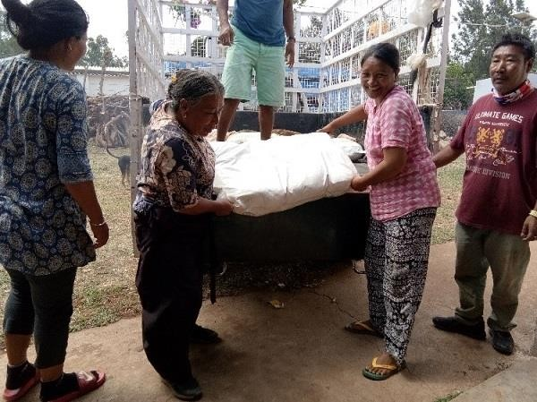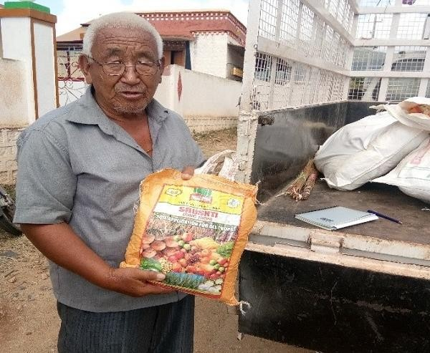

Kollegal farmers receiving micronutrients for soil treatment

* DOH continued work on setting up **KVK demonstration units** in pilot settlements, intended to carry out model organic farming practices and provide extension services and guidance to farmers. In the past quarter DOH’s agriculture consultant began drafting an MOU with the Indian Council for Agricultural Research in Delhi to establish regional KVK centers in Tibetan settlements in central and south India.

# Organic Research and Training Center

* The Organic Research and Training Center (ORTC) in Bylakuppe settlement continued producing affordable plant seedlings at its **nursery**, intended to encourage farmers to explore and adopt new organic cultivation. Saplings of Malabar neem tree, black pepper, avocado, silver oak and a variety of flowers were raised and sold in the past quarter. The nursery also continued raising seedlings for the center’s demonstration plots including green chili, papaya and banana. Regular weeding, application of organic manure and bio- pesticide were carried out.
* A **naturally ventilated poly house** (NVPH) was installed at the nursery. The NVHP will be used to germinate and raise healthy seedlings, especially during the monsoon season, and complements the flat net nursery installed in FY17 with TSRR support. Fruit and non-fruit tree seedlings, flower seedlings, and medicinal and aromatic plant seedlings will be raised in the NVPH, and a micro sprinkler system will be installed in the next quarter.

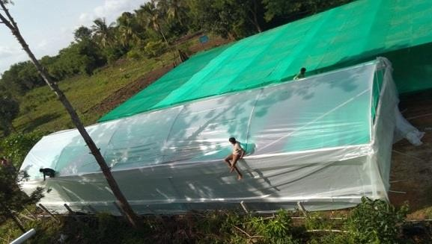

Naturally Ventilated Poly House at ORTC

* ORTC staff continued regular cultivation maintenance work on **banana and coffee demonstration plots,** including weeding, manuring and watering. An additional 3,000 banana suckers were transplanted to 1.5 acres of land. Intercropping of the banana plants with yam and papaya will be completed in the next quarter. Green spinach planted on demonstration plots was harvested and sold to a local monastery. Organic manure, micro nutrients and vermicompost were applied to vegetables, banana and coffee plants.
* ORTC completed land preparation and cultivation of **high protein maize** on five acres of demonstration plot. Maize is the largest crop in Tibetan settlements and is currently cultivated as a low value commodity crop, used primarily for animal feed. DOH plans to convert maize production into higher value products that can command better returns for farmers. In the next quarter cultivation of new varieties of sweet baby corn and high protein maize will be piloted with individual farmers in Karnataka. If successful the pilot is expected to become a model that can be adopted by other maize farming households.
* ORTC installed two new borewell pumps to improve the center’s **irrigation system**. Digging trenches and laying down irrigation pipelines will be completed in the next quarter. In addition, **digital mapping** of ORTC’s land was completed. Electronic stations and drones were used to digitally map land contours, slopes, existing structures, and topography. This information will be used to plan landscaping, establish cropping patterns on demonstration plots, and help in planning the best use of farmable land.

# Regional Agriculture Extension Centers

* In Chandragiri settlement in Odisha, DOH continued preparing **demonstration plots** to cultivate high value crops including maize and turmeric. Based on soil test reports, 3,000 kgs of dolomite lime stone powder was applied, and 800 kgs of turmeric seed was procured. Cultivation will start in the next quarter. Applications were submitted for government subsidies for a new irrigation system for 50 acres of farm land. However, due to state government backlogs, installation has been delayed. A farmers’ meeting was

organized by the AEO to discuss cultivation challenges and precautions and CTA’s land

lease policy. 27 farmers participated in the meeting.

* In Mundgod settlement, cultivation continued of seedlings and saplings at the TSRR- supported **nursery**, including 1,000 seedlings of areca palm and different varieties of flowers. Repair work on the nursery shade net was carried out after heavy rain and strong winds damaged part of the nursery shade. Regular maintenance work was carried out and organic manure and biopesticides were applied. The nursery is intended to promote backyard horticulture and floriculture and provide opportunities for farmers to earn additional income.
* **Digital mapping of demonstration plots** was completed in Mundgod, and agriculture extension staff conducted regular maintenance work on areca nut and banana plots. A farmers’ meeting to distribute soil health cards and discuss soil treatment micronutrients and dosages was also held. 33 farmers took part in the meeting.
* In Miao settlement, a TSRR supported **nursery** continued to raise high-quality tea seedlings using leaf propagation techniques. The nursery raised and sold more than 44,000 high yielding tea saplings to local farmers. Regular maintenance and watering of newly germinated saplings, weeding, and spraying of bio pesticides were carried out. Repair work was carried out after heavy rain damaged a section of the nursery shade net. Raising tea seedlings is expected to encourage farmers to bring more acreage of land under organic tea plantation in Miao, where DOH plans to set up a mini tea leaf processing unit following a technical feasibility assessment.
* **Trainings and exposure visits** were organized for 45 farmers in three settlements in south and central India, in partnership with horticulture and agriculture departments of Karnataka, Chhattisgarh and Odisha state governments. 13 farmers from Kollegal settlement, 15 farmers from Mainpat settlement and 17 farmers from Odisha settlement visited regional KVK centers to attend talks by experts and observe cultivation techniques and best practices. Farmers received training in plantation management, intercropping, field preparation, crop selection, pest and disease control, and storage, packaging and marketing of finished products. To improve agriculture extension services, laptops were provided to AEOs in Bylakuppe, Mainpat, Kollegal, Hunsur, Tezu, Tenzingang, Miao, Odisha, and Mundgod.

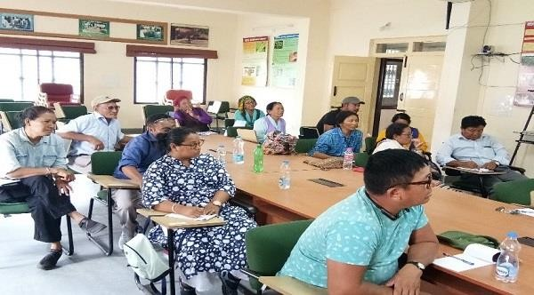 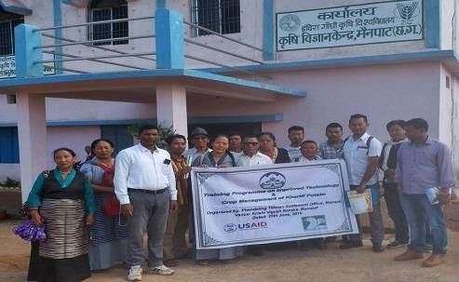

Farmers in Kollegal and Mainpat settlements taking part in training and exposure visits

* DOH organized a meeting to review and update the **Tibetan Organic Agriculture Policy** formulated in 2002. Senior officials including CTA Home Department Kalon, Secretary and 41 Tibetan settlement officers took part in the meeting held in Dharamshala. Key issues including changing trends in agricultural practices, declining interest of youth in farming, lack of technical resources, and proper marketing strategy were discussed. As a next step in gathering inputs for reviewing the policy, settlement officers were instructed to hold interactive meetings with farmers and other stakeholders. Senior DOH officials and an agriculture consultant will be reviewing the feedback and comments from the settlements and begin drafting updates for the policy.
* Annual **organic certifications** were renewed for farmers in Mainpat, Mundgod, Kollegal and ORTC Bylakuppe, following an external evaluation and inspections conducted by IMO Control, a Bangalore based certification agency. Farmer data was also uploaded on TraceNet, a Government of India web-based service that facilitates the organic certification process.
* A team of scientists from the National Dairy Research Institute and National Institute of Animal Nutrition, both based in Bangalore, conducted a **dairy development feasibility study** in Tibetan settlements in Karnataka. The experts visited all the five major settlements in Bylakuppe, Hunsur, Kollegal, and Mundgod. The team’s report is expected in the next quarter.

# Cash crop value addition and marketing

* TSRR supported organic cashew trees in **Chandragiri** yielded their first harvest, which was sold to a local trader. 70 acres of organic **mango and cashew** trees were planted with USAID funding in FY17. Maintenance work on the plantation area continued with regular weeding, manuring and keeping stray animals away. Intercropping of the plantation area with vegetables and beans is planned in the next quarter. Water quality tests for newly dug borewells were conducted. 21 households are expected to benefit from fruit marketing and the plantation is expected to demonstrate a model of organic agro- horticulture that can be adopted by other households in the future.

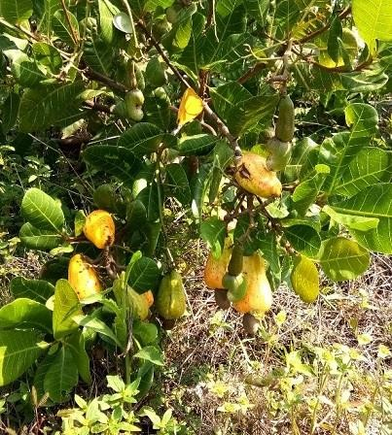 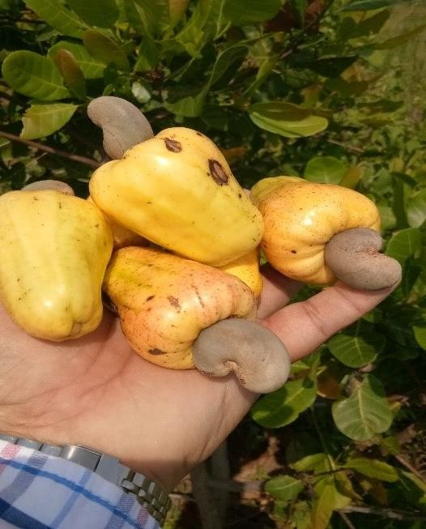

First harvest of cashew crops in Odisha settlement

* Maintenance work continued on 65 acres of organic **mango and cashew** trees in Mundgod. Following a survey of plantation sites, 900 cashew nut seedlings were distributed to replace damaged seedlings. The AEO conducted regular monitoring and supervision visits and oversaw plantation of the new seedlings. 24 households are expected to benefit directly from cash crop production and marketing when trees begin bearing fruit.
* Farmers continued maintenance work on 18 acres of **apple and kiwi** saplings in Tenzingang settlement. Under the supervision of the AEO, farmers installed T-bars and wires to support the growth of kiwi plants. 165 kgs of soybean seeds were distributed to farmers for intercropping and guinea pepper was intercropped on the regional agriculture extension center’s kiwi demo plot to increase farm productivity. Also, 35 farmers attended a meeting organized by the AEO to discuss prevalent pest and disease risks and preventive measures. 30 households are expected to benefit directly from cash crop production and marketing when saplings begin bearing fruit.
* The DOH continued working with Ingenus Strategy and Creative Research to develop a **mini tea factory** in Miao. In the past quarter little progress was made in securing a no objection certificate (NOC) from the Government of India’s Ministry of Environment and Forests (MOEF) to use settlement land for the mini tea factory. DOH and settlement staff along with consultants had earlier held meetings with the Directorate of Small Tea Growers in Dibrugarh, the Tea Board Licenses Head in Kolkata, and Divisional offices in Guwahati.
* In Nepal, 11 farmers from Jampaling settlement took part in an **exposure visit** to Kailali district in southern Nepal to observe different banana farming methods and successful agribusiness models. Farmers visited a banana farm where they learned about banana

sucker management, drip irrigation, different species of bananas, manuring, harvesting, and pest management. They visited an agro-tourism restaurant which focuses on banana dishes. Farmers also visited a vegetable cultivation farm and a ‘climate smart village’ practicing climate responsive farming.

* Jampaling farmers also attended a one-day training on **papaya transplantation**. 550 saplings germinated in the papaya nursery were transplanted following the training, and 125 saplings were distributed to each household in the community. A fence was installed around the community pineapple farm to prevent theft and damage of plants by animals.

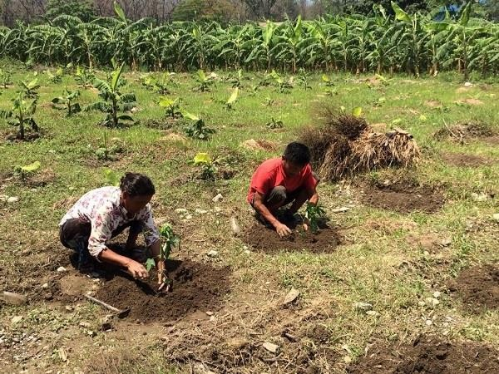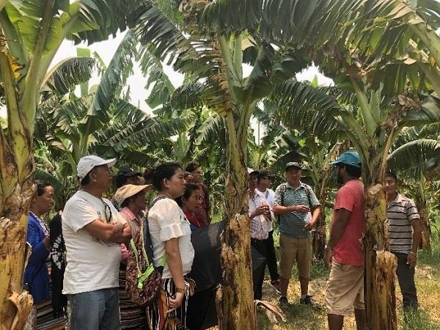

Jampaling papaya transplantation (left) and banana farming exposure visit (right)

* 100 lime saplings were planted to replace unproductive plants in a USG-funded **community cash crop plantation** in Jampaling, where regular maintenance work continued. Community laborers were hired to conduct maintenance work on the irrigation canal, from which mud and other residue were removed to improve water flow.
* In Tserok settlement farmers continued regular weeding, manuring and maintenance of TSRR funded **apple orchards**. The AEO visited the settlement and observed that the new saplings planted in the previous quarter were growing well. Following concerns over pest management, an expert from the government Temperate Horticulture Development Center visited the settlement to provide pest management and control guidance to farmers.
* In Dhorpatan settlement a training on **potato and vegetable cultivation** was conducted by experts from the GON’s District Agriculture Development Office. 14 farmers learned new cultivation and post-harvest management techniques for vegetables including potato, radish, and carrot. Farmers actively took part in the training’s theoretical sessions and practical demonstrations.

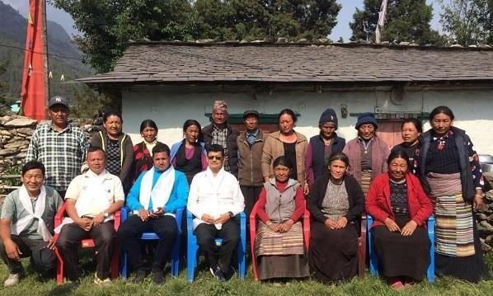

Potato and vegetable farming training participants in Dhorpatan

* 18 farming households in Dhorpatan received nursery supplies including small plastic tunnels, watering cans, biopesticide sprayers, black plastic and microorganisms for making compost. Households had earlier received potato and vegetable seeds for nursery cultivation including spinach, cabbage, coriander, swiss chard, bock choy, carrot, radish, cauliflower and zucchini.

# KRA 4: BASIC EDUCATION STRENGTHENING

In 2012 USAID began supporting basic education strengthening for Tibetan children with the Tibet Education Project (TEP). The Tibetan exile education system serves roughly 21,000 children in grades K-12 through a network of 75 schools in India and Nepal. TEP reached a total of 20,866 students in these schools from 2012-2017, delivered training to 1,152 teachers and school leaders, and provided higher education scholarships to 637 students.

With the inception of TSRR, a diagnostic assessment was conducted to provide evidence-based recommendations to inform phase II planning of KRA 4. Key recommendations included integrating ICT with classroom instruction, extending the existing EGR model up to grade 5, collaborating with a reputed STEM education organization to provide high quality STEM instructional training and resources, strengthening counseling to address issues related with students’ career planning and corporal punishment, and providing high quality professional development opportunities for school heads to enhance their educational leadership skills. While the assessment was being conducted, in FY17-18 TSRR supported continuation of strategies begun under TEP; phase II of this program component began in FY19 Q1.

# Educational Information and Communications Technology (ICT)

Based on assessment recommendations a new educational technology initiative was piloted in four Tibetan schools in FY18, including ICT infrastructure improvement in four schools, development of ICT policy guidelines, and teacher training in ICT-based educational tools and strategies. In FY19 the program extended this initiative to four more schools. In addition, basic ICT infrastructure is being improved for eight schools with limited resources.

# Activity progress:

* + - Plans were finalized to review the pilot ICT program in four schools in the next quarter. Led by Dr. Amina Charania, an Associate Professor at Tata Institute of Social Sciences, a team of experts will conduct the review and provide follow-up mentoring support to about 30 middle school teachers. Experts will observe ICT based classroom lessons and provide feedback to teachers on how to further improve classroom instruction using ICT. Planning also continued to install 20 **classroom technology corners** in four additional schools (STS Mundgod, STS Chandragiri, STS Kollegal and Upper TCV) to enable technology integration with classroom instruction.
    - Eight schools completed school-based **digital literacy workshops** conducted by computer instructors to a total of 165 middle school teachers. In the next quarter, four Tibetan ICT trainer-mentors to conduct school-based workshops for 60 teachers in four schools. The workshops will cover ICT-based learning theories and approaches, use of ICT tools in classroom teaching, adoption of technology in schools and the role of teachers.

# Early grade reading skills improvement

To address EGR related challenges including Tibetan children’s inadequate levels of reading comprehension in mother tongue and dearth of grade-appropriate, high quality reading materials in Tibetan, the TEP introduced the Tibetan Early Grade Reading (TEGR) program in 2013, a multi-component initiative that has supported production of the first Tibetan language graded reading series; Tibetan translations of high quality children’s books; installation of classroom reading corners with grade-appropriate Tibetan reading materials; EGR training and mentoring for primary teachers and librarians; improvement of school library collections; EGR workshops for parents; and design of an assessment tool to measure improvement in early grade reading skills. In FY17-18 TSRR supported printing of Tibetan language graded reading series and Tibetan translations of children’s book, new children’s literature publication, EGR training and support for educators and EGR workshops for parents.

In FY19 TSRR is continuing its support for EGR activities including publication of new children’s literature, EGR training and support for educators, and EGR workshops for foster parents. In addition, installation of CRCs in Grades 4 and 5 classrooms is being supported as an initial step to extend the existing EGR model up to Grade 5 in all schools.

# Activity progress:

* + - **Translation and illustration work** was completed in preparation to publish ten Tibetan language children’s books, bringing the total of USAID supported Tibetan language children’s literature to 68 new and newly translated titles. A review meeting was held to ensure syntax simplicity and use of child friendly language. The final review meeting will be held in the next quarter, after which 3,000 copies each of all 10 titles will be printed, totaling 30,000 copies. 27,250 copies will be distributed to schools and parents in India and Nepal.
    - In FY17, a set of 18 new children’s book translations and a graded reading series of 40 new children’s book titles were produced under the USAID supported Tibet Education Project. Of the 16,600 sets printed, 6,009 remained undistributed at the end of the second quarter of FY19 (4,560 sets of the 18 translated titles, and 1,449 sets of the 40-title graded reading series). In the past quarter, 14 sets of translated titles and 196 sets of the graded reading series were distributed to parents in Tibetan settlements in Central and Northeast India. In the next quarter 606 sets of translated titles will be distributed to Tibetan parents in Shimla, Bylakuppe, Sikkim, Mainpat, Odisha and the Dehradun region.
    - 19 teachers from 14 schools in Himachal Pradesh and Uttarakhand region attended a three-day **EGR primary teacher training** led by experts from Ignus Pahal, a reputed education consultancy company focusing on EGR. The training covered important EGR related topics including concepts and processes of language learning, constructivist approaches to learning, reading assessment and personal improvement plans. In the next quarter, a similar training will be held in Bylakuppe for about 30 primary teachers from 10 schools.
    - Two **EGR workshops for pre-primary teachers** were held in Dharamshala. The DOE EGR Coordinator led the five-day workshops for 42 pre-primary teachers, which emphasized the importance of reading for comprehension and strategies to enhance reading skills, such as storytelling, poetry recitation and singing. School librarians will receive similar EGR workshops in coming years.
    - **EGR workshops for parents and foster parents** were conducted in three Tibetan settlements in South India. 294 parents and foster parents benefitted from these workshops which emphasized the importance of creating a conducive atmosphere for reading at home and developing the habit of independent reading in children. Parents were also educated about selecting good stories for children and the art of storytelling.
    - Installation began of 30 **classroom reading corners (CRCs)** in grades 4 and 5 classrooms in ten schools. Guidelines on how to install CRCs were sent to schools along with funding for materials and local labor costs. Each CRC will be stocked with a collection of high quality Tibetan and English children’s books. Work also began to improve **library furniture and book collections** at eight schools.
    - In Nepal, a team of experts from Room To Read (RTR) began preparing to conduct a **diagnostic assessment** to develop a more effective and locally appropriate EGR strategy for Tibetan primary schools in Nepal. Ten teachers participated in a workshop led by RTR to develop a student assessment tool. In addition to student assessments and classroom observation, information on EGR practices will be collected through interviews with teachers, school leaders and parents. A **language mapping survey** will also be conducted among teachers. Based on assessment recommendations a multi-year EGR strategy will be designed that is specific to the Nepal context.

# Teachers and educators training and professional development

Provision of high quality pre-service and in-service professional development opportunities is crucial to ensure the best learning outcomes for students. In FY17-18 TSRR supported continuation of a four-year pre-service teacher training course, a preservice training course for pre-primary teachers, a Tibetan language teacher pre-service training, school-based teacher professional development activities (SBTPD) and teacher reading corners for school-based professional development. In addition, a 20-month pre-service training course for pre-primary teachers was supported, and new sensorial teaching aids were piloted in five pre-primary schools.

In FY19 the program is continuing its support to four-year pre-service teacher training, Tibetan language teacher pre-service training and SBTPD. In addition, the program is supporting in- service training for pre-primary teachers and provision of sensorial teaching aids to pre-primary classrooms.

# Activity progress:

* + - 40 Tibetan schools received small grants to carry out **school-identified teacher professional development activities** such as on-site TPD workshops, expert talks, book discussions, lesson study groups and observance of Professional Development Day. About 1,000 teachers are expected to benefit from these activities.
    - 28 school principals and headmasters attended a **teacher professional development and leadership training for school heads** in Dharamshala. Senior Tibetan educators and administrators including Dr. Pema Yangchen, the CTA Education Kalon, Namgyal Yemphel, Director of Sambhota Tibetan Schools Society, Karma Chungdak, General Secretary of Tibetan Homes Foundation, and Tenzin Dorjee, head of the DOE Academic Section, conducted sessions on TPD related topics ranging from instructional leadership and the importance of teaching portfolios to positive disciplining and parental involvement in education. The six-day workshop was intended to enable school heads to better guide and support their teachers in implementing TPD activities in schools.

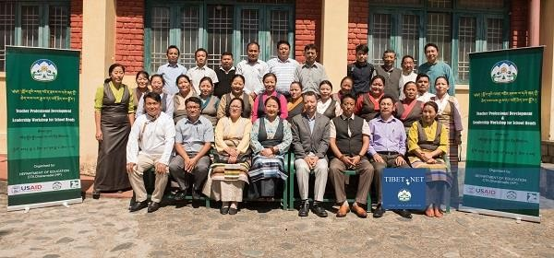

TPD and leadership training participants in Dharamsala

* + - Planning continued to organize **Higher Order Thinking Skills (HOTS) workshops** for 45 teachers in three pilot schools including STS Chauntra, STS Paonta Sahib and STS Petoen schools. The workshops will focus on introducing a new **Tibetan language HOTS Handbook**, drafting of which began in FY18 with TSRR support. After the training, 1,000 copies of the handbook will be printed and distributed in all Tibetan schools.
    - 29 middle school teacher-trainees completed their **trained graduate teachers (TGT) pre- service training** at the Central University for Tibetan Studies (CUTS) in Sarnath. Before appearing for their final semester examination in May, the trainees visited Jeevan Jyoti School in Varanasi to observe the functioning of a special education school. They also attended a lecture on Origin of Monastic Sangha in Tibet given by an assistant professor at CUTS. Trainees will be contacted after six months to learn how many of them have received job placements in Tibetan schools.
    - **Tibetan language teacher pre-service training program** continued for 20 trainees at the College for Higher Tibetan Studies, Sarah. Trainees visited three schools to observe activities and facilities including classroom teaching, morning assembly, library activities, hostel conditions and sports facilities. The college also arranged a three-day visit for trainees to Tonglen School for underprivileged Indian Children to observe how Social Emotional and Ethical Learning (SEE Learning) Curriculum is being delivered in classrooms.
    - Ten sets of **pre-primary sensorial teaching aids**, twelve sets of math teaching aids and 17 sets of everyday practical life (EPL) teaching aids were distributed to 13 pre-primary schools. In the next quarter 30 pre-primary teachers from 22 schools in South India will receive Montessori methods training, through which they will learn how to use the teaching aids.
    - In Nepal, nine school leaders from schools in Kathmandu and Pokhara attended a **teacher professional development (TPD) refresher training** at Srongtsen school in Kathmandu. Trainers from the School of Education, Kathmandu University, led the two-day training, which focused on approaches to TPD and developing TPD plans in schools. Participants shared their ideas on developing teacher reading corners, teacher exchange programs, and

appointing teacher mentors. Prior to the training SLF management and participants discussed new requirements in schools due to changes under the Government of Nepal’s new federal system.

* + - 19 teachers participated in a separate **teacher professional development training** conducted by a TPD specialist from the CTA Department of Education. The four-day training focused on collaborative practices including observation cycles, lesson study groups and group book discussions, and introduced approaches for teachers to measure and improve their own individual professional growth. Opportunities and possibilities of implementing the CTA’s Basic Education Policy in the context of Nepal were also discussed. Participating teachers assumed the responsibility of acting as TPD coordinators in their respective schools, and the TPD specialist visited seven schools in Kathmandu and Pokhara to provide additional on-site guidance to school staff.

# Science and math education strengthening

Science and math learning continues to be a challenge for many Tibetan children and remains a key priority for the DOE. In FY17-18 the program supported supplementary science lessons that provide students with innovative learning materials; an exhibition for students to create working science models; and science research internship opportunities intended to enhance their interest in scientific research. In FY19 the program is continuing to support science exhibition and research internship opportunities for students, and is introducing a pilot STEM strengthening initiative in six schools.

# Activity progress:

* + - Two experts from the Aavishkar Center for Science and Math Excellence visited seven schools in the Dharamshala region to observe and provide on-site **mentoring** to 36 middle school science and math teachers. The experts observed classroom lessons and provided feedback to individual teachers on specific areas of improvement. The experts found the majority of teachers focus on exam preparation and emphasize fact memorization rather than deeper conceptual understanding. They also found two-way discussions lacking in most classrooms and observed limiting opportunities for students to ask questions, debate, and disagree over concepts.
    - 34 students from 14 schools took part in a multi-school **science exhibition** at TCV Suja in Himachal Pradesh. Participants displayed exhibits on the theme ‘Scientific Solutions for Challenges in Life,’ including working models and presentations of student research on topics ranging from water and waste management to health and agriculture. A panel of judges selected six exhibits for entry into a national science, math and environment exhibition organized by the National Council of Education Research and Training.
    - Nine college students completed month-long internships at the National Institute of Biological Science and Indian Institute of Science Education and Research, and submitted

their completion reports to the CTA DOE. **Science research internships** are intended to enhance students’ interest in scientific research and encourage them to pursue research in the future.

* + - Planning continued to implement a **STEM pilot initiative** in collaboration with Agastya International Foundation (AIF). In the next quarter 20 STEM teachers will attend a training workshop, after which hands-on science learning events will be organized for students and high-quality science and math teaching materials will be provided to make classroom instruction more engaging.

# Basic Education Policy strengthening

Key aspects of the CTA’s basic education policy (BEP) include an emphasis on teaching and learning of higher order thinking skills and the importance of Tibetan language learning and Tibetan medium instruction. In FY17-18 the program supported talks for parents and other community members on the objectives, principles, and importance of the BEP, a training workshop and mentoring program for teachers, primary classroom improvements and provision of high quality BEP teaching materials for schools including sensorial teaching aids for pre- primary classes and math workbooks and textbooks in Tibetan language. In FY19 the program is continuing to support BEP mentoring for in-service and pre-service teachers, provision of high quality BEP teaching materials for schools including Tibetan language math workbooks and textbooks. In addition, TSRR is supporting a general education conference, production of Tibetan nursery rhyme animation videos, and BEP related workshops for parents.

# Activity progress:

* + - Work continued on translating Maria Montessori’s *Education and Peace* into Tibetan and proofreading Professor Samdhong Rinpoche’s transcribed speeches on BEP. These texts are expected to provide teachers with **BEP-related learning and reference materials**. Work also continued to produce Tibetan language math workbooks for grades 3 and 6 and a Tibetan language math textbook for grade 8.
    - Production of five animation videos of **Tibetan nursery rhymes** was completed and the videos were uploaded on the DOE’s Tibetan language website [www.bodyiglobjong.com](http://www.bodyiglobjong.com/). The videos are expected to facilitate Tibetan language instruction in pre-primary classrooms.
    - A series of five school-based **foster parents workshops** were conducted in four residential schools for a total of 104 foster parents. The workshops were organized in partnership with Tibetan Center for Conflict Resolution, Altmind Shift, and Expression India, and covered important parenting related topics including emotional well-being of children, child development, corporal punishment, POCSO Act, child sexual abuse, conflict resolution, and bullying.
    - Tibetan translation of the **Guidelines for Eliminating Corporal Punishment** was completed. In the next quarter, the guidelines document will be printed and distributed to all Tibetan schools. School counsellors will conduct sessions on corporal punishment with teachers and staff members based on the guidelines.

# School Infrastructure Improvement

In 2013 the Government of India (GOI) announced its decision to transfer all GOI administered schools to the CTA and to date a total of 55 schools were successfully transferred to the Sambhota Tibetan Schools Society (STSS), an educational administration under the CTA Department of Education. Due to years of poor infrastructure maintenance, however, many these schools are in a deplorable condition. In FY19 TSRR is supporting improved school infrastructure in eight of the schools recently transferred to STSS, including furnishing classrooms and administrative offices with furniture including benches, desks, chairs and tables, replacing broken classroom doors, windows, and toilet urinals, procuring electrical supplies and materials including tube lights, wires, switches and sockets, and improving social science teaching and learning materials.

# Activity progress:

* + - Work began to improve school infrastructure and facilities in seven Tibetan schools with the repair and replacement of broken doors, windows and urinals, furnishing classrooms with desks, chairs and notice boards, and procuring electrical supplies and teaching and learning resources. STS Gurupura received 90 sports equipment items including a table tennis board, basketballs, chess boards, stop watches, football pumps and cricket bats.

# KRA5: Access to Higher Education

In 2012-17, USAID-funded scholarships significantly increased the number of Tibetan college and graduate students able to access higher education, and supported career counseling and test preparation coaching to help students improve their competitiveness in gaining admission. In FY17-18, TSRR continued to support scholarships and test prep coaching as well as career counseling in Tibetan schools. Phase II of this component began in FY19.

# Higher Education Scholarships

In FY19 TSRR is providing higher education scholarships to undergraduate and postgraduate students pursuing various liberal arts, professional, and nonprofessional degrees at a wide range of colleges and universities in India.

# Activity progress:

* + - 259 students continued receiving **higher education scholarships,** and nine additional students began receiving new scholarships to pursue undergraduate, graduate and

professional degrees. Of the 268 students, 39% are post graduate candidates, 57% are female, and 8% are residents of Nepal. One student is a resident of Bhutan.

* + - A team of consultants and TTF’s education coordinator completed data collection and analysis for an ongoing **DOE scholarship policy review**. The team analyzed data from focus group discussions and an online survey of 586 scholarship recipients and potential applicants, and prepared an initial draft report. In the next quarter, consultants will hold a meeting with DOE officials to seek their feedback on the report, after which they will make a final presentation highlighting the key findings and recommendations.

# Test Preparation Coaching

TSRR supports test preparation coaching to address competitive admission hurdles faced by students aspiring to pursue medical and engineering studies. Coaching is also provided for grade 10 and 12 students to prepare for the All India Secondary School Examination (AISSE) and All India Secondary School Certificate Examination (AISSCE), centralized high stakes tests conducted by India’s Central Board of Secondary Education (CBSE).

# Activity progress:

* + - 91 secondary students at three schools continued receiving **after-class coaching** to prepare for the Joint Entrance Examination (JEE), a highly competitive exam required for admission to India’s most selective engineering schools. This program was designed by Avanti Fellows, an educational organization in Delhi that specialized in JEE preparation for disadvantaged Indian students.
    - 13 secondary school graduates completed **gap year study scholarships** to prepare for highly competitive entrance exams to gain admission to medical schools. Out of the 13, 12 appeared for National Eligibility Entrance Test (NEET) for admission in medical colleges in India. Two students secured MBBS seats while the remaining 10 opted for other medical courses including dentistry, physiotherapy, nursing and pharmacy. In the next quarter, 10 new students will receive gap year study scholarships.

# Career Guidance and Counseling

As the majority of Tibetan students study in residential schools far away from their families, they receive limited parental guidance and support in career planning. School counsellors play an important role not only in providing career planning guidance but also in addressing psycho-social issues and learning difficulties. However, many schools do not have resident counselors, and must rely on short annual visits of DOE counselors for individual and group counseling. In FY19 TSRR is supporting career guidance and counseling programs including professional counseling in schools, workshops for parents and foster parents on positive disciplining and parenting skills, and school-based career awareness programs.

# Activity progress:

* + - Counselors from Banjara Academy in Bangalore conducted a week-long **professional counseling program** for grade 6-12 students in two Tibetan schools in Karnataka. Focusing on building self-esteem, bullying, aptitude, career planning and identification of psychological problems, activities included interaction with individual students, group interaction with students and teachers, and group counseling. Two newly appointed resident counselors assisted and learned from the team and conducted follow up sessions.
    - A DOE counselor visited five Tibetan settlements in Karnataka to conduct **parental counseling workshops.** Attended by 101 parents in total, the half-day workshops focused on positive parenting and children’s career planning. Parents were introduced to different parenting styles and positive disciplining techniques, and received guidance on how to help their children make career decisions based on their interests and aptitudes.
    - 292 secondary school graduates in five Tibetan settlements in Karnataka attended **career orientation events**. Conducted by a DOE counselor, orientations provided information about college admissions, scholarships and career choices. Career orientation booklets with career related information were also distributed to the participants.
    - In Nepal, 629 grade 6-12 students attended **group counseling** sessions in three schools. Led by a guidance counselor from Snow Lion Foundation (SLF), sessions focused on goal setting and decision making. SLF also began working with the Center for Mental Health and Counseling (CMC) to improve mental and emotional counseling services in schools. An assessment survey of students’ emotional behavior was conducted with 99 teachers and 600 students in three schools in Kathmandu. Following analysis of the data, CMC will present findings and recommendations.
    - SLF organized an **exposure visit** to six reputed colleges and professional institutions in the Kathmandu valley to observe college campus activities and interact with college admissions staff. 59 graduating students from Namgyal Higher Secondary School visited Sowa Rigpa International College, Vajra College, Thames College, Nepal College of Travel and Tourism Management, K&K International College, and Shankar Dev College. Selection of these six colleges was based on student interest, college affiliation, popularity, past placement records, availability of relevant courses, provision of scholarships, and school facilities. Students had the opportunity to interact with teaching and administrative staff and learned about scholarship options, admissions, and documentation requirements.

# KRA 6: COMMUNITY HEALTH IMPROVEMENT

In 2015 USAID began supporting the CTA Department of Health (DOH) to address community health challenges through the Tibetan Health System Capacity Strengthening Project (THSC). Key THSC strategies were strengthening the Tibetan Medicare System (TMS); improving the quality

of TB care and reproductive, maternal, newborn, child, and adolescent health (RMNCHA) services; improving preventive healthcare seeking behavior; and improving the quality, utility, and coverage of the DOH health information system (HIS). To increase long-term financial sustainability THSC also introduced new health financing models. Strategies were informed by a comprehensive assessment of the DOH health system conducted in 2015-16, and a multi-year road map was developed by the DOH with support from TTF and USAID. A review of THSC results and lessons was conducted in 2018, and in FY19 TSRR began supporting continuation of core THSC strategies.

# Activity progress:

**Tibetan Medicare System**

* + - DOH confirmed total **TMS enrollment** for the current 2019-20 subscription period to be 27,496 members, consisting of 5,863 families and 1,267 individuals. This represents a 109% increase over total enrollment prior to USAID support (13,151 members in 2014-

15) and a 13% increase compared to the last subscription period. In the first quarter of the 2019-20 subscription period, from April to June, 461 TMS members received medical expense **claim reimbursements** totaling INR 3,897,986 (approximately $55,600).

* + - DOH reported total TMS membership revenues and claims payments for the 2018-19 subscription period to be INR 22,166,178 and INR 22,233,410, respectively, representing a **claims ratio** of slightly more than 100% for the year. By comparison, this represents a 7% increase from the previous year’s claims ratio. However, prior to USAID support claims ratios were 129% in 2012-13, 189% in 2013-14, and 176% in 2014-15.

# Tuberculosis Care and Management Services

* + - In the past quarter culture and **drug sensitivity testing** (DST) was conducted for 128 TB patients to identify whether bacteria are resistant to one or more of the main TB drugs, and to help determine the most effective treatment for multi-drug resistant (MDR) TB in a timely manner. DST sputum specimens were collected at hospitals in five of the largest Tibetan settlements in India and sent to Hinduja Hospital in Mumbai for analysis. DOH works in collaboration with Delek Hospital in Dharamshala to provide this high-quality service. 200 GeneXpert cartridges were purchased in the last quarter to conduct nucleic acid amplification tests for rapid and reliable TB diagnosis at Tso Jhe Hospital in Bylakuppe.
    - 28 patients received short course chemotherapy (SCC) and 23 patients received multi- drug resistant (MDR) **medicine support**. In addition, 20 economically vulnerable patients in India and two patients in Nepal received **special diet and nutrition** support. Also, Annual Maintenance Contracts (AMCs) for TB diagnostic equipment including X-Ray machines and computed radiography systems at hospitals in Mundgod, Kollegal, Bylakuppe, Dekyiling, Bir, and Mainpat were renewed.
    - DOH staff conducted supervision and monitoring visits to nine settlements in north east, south and central India to review implementation of TB programs and establish linkages with regional GOI TB centers. In Tezu, Tenzingang, Ravangla, and Odisha settlements DOH and local hospital staff met with district TB officials to strengthen communication and referral systems between host government TB care providers and Tibetan health care workers. In Sonada settlement TB prevention, early detection, and symptoms were discussed with Tibetan school authorities and hostel administrators. In the south settlements of Mundgod, Hunsur, Kollegal, and Bylakuppe, DOH staff observed that TB cases have declined significantly. The TB DOTS program and reporting TB data online in the RNTCP Nikshay portal were discussed with hospital staff.

# Reproductive, Maternal, Newborn, Child and Adolescent Health

* + - 193 vulnerable pregnant women in India and six pregnant women in Nepal received **antenatal care** including TT injections, lab tests, ultrasound tests, traditional and non- traditional micronutrients, neonatal vitamins, and delivery allowances. In India services were provided by DOH health workers in coordination with local hospitals, and in Nepal services were facilitated by community health workers in coordination with SLF and local hospitals.
    - Visiting gynecologists continued providing care and services to newborns, mothers and expecting mothers in two settlements. In Mundgod, 29 pregnant women received **antenatal services** including follicle stimulating hormone tests, contraction stress tests, and pap smear tests. In Miao, four pregnant women received antenatal care.
    - DOH began providing special **nutritional diets to crèche children** in the remote areas of Ladakh and Miao settlements, including milk, eggs and fruit. The program aims to prevent malnutrition and promote healthy nutrition for the most vulnerable children. DOH prioritization of children in Ladakh and Miao is based on the relatively higher risk of malnutrition in these settlements due to their remoteness.
    - 22 nurses and health workers from more than 20 settlements attended a two-day **RMNCHA refresher training** in Delhi. Sessions focused on current RMNCHA issues in the Tibetan community, health education methods and RMNCHA related communication with family members and community members, sexually transmitted infections, the role of nurses in adolescent health and antenatal and postnatal care, and the CCOCC program.
    - Piloting began of a new ‘**Achala’** program to promote well-being, good nutrition, and healthy lifestyles, and prevent diabetes, hypertension, and other noncommunicable diseases (NCDs) among Tibetan women, in particular elderly and middle aged post- menopausal women and mothers. 23 women in Bir settlement and 80 women in Dekyiling settlement took active part in Achala yoga and Zumba classes.
    - To promote menstrual health and hygiene among school girls a **sanitary pad vending machine and disposal kiosk** were installed at Sambhota Tibetan School in Paonta Sahib. Sanitary pads were provided and a disposal kiosk was installed at TCV School in Gopalpur where, as part of TSRR’s women empowerment initiative, a sanitary pad vending machine was installed last year.
    - A campaign of **anemia screening and prevention** for Tibetan school girls continued. 979 girls underwent HB tests in five schools in Kollegal, Ladakh, Suja, and Chauntra settlements, and 157 girls began taking iron tablets based on test results.
    - In Nepal, SLF coordinated with Nepal Fertility Care Center (NFCC) to deliver **HPV vaccinations** for students in five schools in Kathmandu and Pokhara. The first dose of vaccine was administered to 399 girl students in grades 6 and above, and the second dose will be administered in the next quarter. Government of Nepal protocols were followed and a GON-authorized vaccinator conducted orientations for school nurses and HPV awareness sessions for girl students.

# Social and Behavior Change Communication

* + - Susan Shulman, a U.S. based SBCC specialist, continued working with DOH and SLF staff to develop **SBCC strategies and plans** for new health prevention campaigns, activities and messages. DOH and SLF staff visited settlements to conduct focus group discussions on selected health behavior topics including diet, exercise, condom use, and Hep B vaccination. They reanalyzed HIS data, drafted program briefs, and prepared knowledge, attitudes and practices (KAP) and socio-ecological tables based on research data. The SBCC specialist and Dawn McCown, Senior Advisor at USAID, India, will lead the next workshop in Dharamsala in July, after which they will guide DOH and SLF staff to develop SBCC strategies based on field research findings.

# Comprehensive Community Outreach and Coordinated Care

* + - Facility health workers continued conducting CCOCC household visits in their settlements using point of care testing (POCT) kits, Pico projectors, educational flipbooks, and animated videos. POCT kits were used to check Hb, RBS, urine and blood group for community members. TB related outreach included DOT services, follow up and reminders and presumptive TB findings, contact tracing and intensified case finding. RMNCHA related outreach included ANC and PNC follow up, vaccine reminders and child feeding advice.
    - DOH staff conducted supervision and monitoring visits to ten settlements in south, central and northeast India to review implementation of CCOCC services and provide on-site training to outreach staff. The team reviewed outreach worker job descriptions and discussed CCOCC implementation status and challenges. Needs were identified to strengthen supervision of CCOCC activities in smaller clinics, incorporate CCOCC reporting

in DHIS2, increase household coverage, and improve timely reporting of outreach activities.

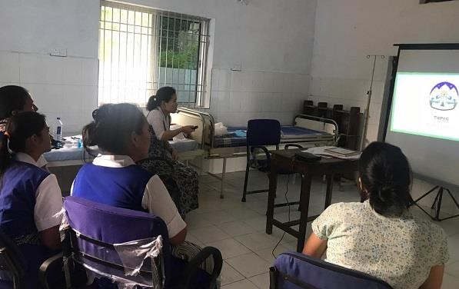

Health workers attending CCOCC training in Dekyiling

# Health System Strengthening

* + - The DOH conducted an in-depth on-site **analysis of settlement health facilities** in Ladakh and Odisha. Information on hospital patient load, utilization of hospital resources, availability of services including emergency, dental, laboratory, physiotherapy, delivery, and outreach services, manpower requirements, financial revenue and expenses, and community needs were collected through individual interviews and group discussions with hospital staff and settlement camp leaders. Optimal service model (OSM) objectives and strategies were also discussed with hospital administrators and health workers.
    - Piloting began of a new service, **H. pylori antigen testing,** at six OSM facilities to detect infection by this disease, which causes stomach cancer and is highly prevalent among Tibetans. Rapid testing H. pylori kits were procured in Hunsur, Kollegal, Bylakuppe, Mundgod, Odisha, and Dekyiling settlements and tests are expected to begin next quarter.

# Health Information System

* + - 27 health workers attended a three-day **Open MRS refresher training**. Designed for staff from hospitals in Bylakuppe, Hunsur, Mundgod, and Kollegal that use Open MRS software, the training was led by experts from Health Information System Programmes Network (HISP). Implementation challenges and customization requirements were discussed along with theoretical and practical sessions on software features including billing modules, OPD and IPD modules, laboratory modules, and inventory and pharmacy.
    - A team of DOH and HISP staff conducted **regional monitoring visits to review HIS implementation** at DTR hospital in Mundgod and Menlha hospital in Odisha. The team met with hospital staff and discussed DHIS2 software and Open MRS implementation and challenges. On the job training was provided and Open MRS billing issues were identified and resolved.
    - DOH began **piloting DHIS2 at selected school and monastery clinics**. DOH staff and health facility workers visited Upper TCV school and Dolmaling nunnery in Dharamshala and Sambhota Tibetan School in Chauntra to provide initial orientations and introduce the application to clinic staff.

# KRA 7: PARTICIPATORY COMMUNITY DEVELOPMENT

In 2017 TSRR began introducing a participatory approach to community development in Tibetan settlements, intended to address community-identified needs while maximizing local ownership of program support. During participatory needs assessment (PNA) meetings led by trained facilitators, community members identify local development needs and priorities. Technical and cost analysis is then conducted, and TSRR funding is used for community-identified priorities activities after prior TTF and USAID approval.

Implementation of this program component has faced multiple challenges and achieved poor results overall in FY17-18. Problems stemming from low capacity caused long delays between initial PNA meetings, completion of feasibility analyses, and delivery of support for community identified priorities. As a result, some settlements where PNAs were completed in FY17-18 have still received no support. In FY19 Q2-Q3, TTF conducted a mid-term process review in India, and assisted the Department of Home in formalizing new implementation guidelines. In Nepal, a similar mid-term review will be conducted in Q4, and an improved strategy will be developed to improve results for the remainder of the program.

# Activity progress:

* + - A **new procedural outline to improve the FY19 PNA process** was finalized following a series of review meetings with senior DOH and SARD officials and consultations with participatory development experts and DOH PNA facilitators. Based on past experience and best participatory development practices, the new guidelines focus on decentralizing needs identification and prioritization to communities at the settlement level in order to improve participation and ownership and also increase efficiency of the process. The new guidelines lay down a systematic Pre-PNA, PNA, and Post-PNA process, as follows:

During the **Pre-PNA** a series of exercises are conducted by DOH’s PNA facilitators (PNAF) along with the local settlement officer (SO) and community mobilizer (CM), including resource mapping, stakeholder analysis, transect walk, and creation of a seasonal calendar, trainline, and institutional diagram. PNAFs also disseminate general information on TSRR and CD-ISDP, the importance of PNAs and the PNA process, results

expected, and terms and conditions regarding the submission of need-based lists and donor cost restrictions against constructions.

In **PNA Phase I**, stakeholder group meetings are facilitated by PNAFs, beginning with a presentation of Pre-PNA findings, followed by an exercise to identify community success stories and strengths and then an open-ended listing of proposed projects to address the group’s perceived needs. PNAFs and CMs then use a combined pairwise and open ranking exercise to prioritize the top 10 (or fewer) proposed activities and facilitate a basic risk assessment of each. The option is then introduced of Livelihood Affinity Groups (LAGs) and/or individuals proposing additional activities, along with guidelines and eligibility criteria.

Following an overnight or day’s break for reflection, a settlement-wide community meeting is held at which each stakeholder group presents its list of need-based priorities to the whole community. PNAFs and CM use a combined pairwise and open ranking exercise by which all community meeting participants prioritize the top ten (or fewer) activities proposed by stakeholder groups. A similar ranking exercise is used to prioritize the top 10 (or fewer) activities proposed by LAGs and/or individuals.

Toward the end of the settlement-wide community meeting, PNAFs and CM request everyone to make a personal commitment of something (no matter how small) they can do themselves to contribute to the community without financial input, e.g. planting a tree or cleaning around their house. PNAFs and CM then assist the different stakeholder groups, LAGs, and/or individuals to fill in more detailed information sheets for their respective top-ten proposed activities and conduct a more in-depth risk assessment of each.

In **PNA Phase II**, settlement visits are conducted by senior DOH officials to review the final list of community-prioritized activities on the basis of practicability, viability, beneficiary inclusiveness and sustainability. With the SO and CM, senior officials select the top five (or fewer) of these, and concerned project holders are asked to prepare more detailed proposals for each with guidance and support from SO and PNAFs.

During the final **Post-PNA** phase, a central committee of DOH and SARD officials and a TTF representative meet in Dharamsala to review and approve the final detailed proposals collected from settlements. Community-identified priorities are then submitted to USAID for pre-approval.

* + - Prior to conducting PNAs at seven new settlements (see below), DOH’s two PNAFs received a day-long **PNA refresher training** at PRAXIS Institute of Participatory Practices in Delhi. The training focused on participatory tools including resource mapping, seasonal calendar, pair-wise ranking and risk assessment. The trainers conducted mock PNA sessions and then visited Tenzingang and Darjeeling to support PNAFs in conducting PNAs.
    - In the past quarter DOH conducted **PNAs at Tenzingang and Bomdila in Arunachal Pradesh, Gangtok and Ravangla in Sikkim, and Darjeeling, Kalimpong and Sonada in West Bengal**. PNAFs were successful in following the new PNA procedural guidelines in Tenzingang, Ravangla and Sonada as these are proper settlements with the local Tibetan population living together in camps within a single continuous periphery. PNAFs faced

challenges following the new guidelines in the other settlements, however, as these comprise of several small clusters of households, located more than a hundred kilometers apart in some cases. PNAFs therefore had to make adjustments in the process, and held PNA meetings with representatives of cluster communities and active members of local Tibetan grassroot associations and groups.

* + - In **Tenzingang** settlement, a PNA was conducted over a period of 7 days. A pre-PNA meeting to discuss the concept and objectives of PNA was held with TSO staff, camp leaders, and representatives from NGOs and a cooperative society. Expectation mapping and perception mapping exercises were held followed by drawing of a seasonal calendar and a resource mapping exercise to identify available resources in the settlement. Participants concluded the pre-PNA session with a transect walk in each of the four camps to explore, ask, listen, and observe settlement conditions. The PNA process began with identification of three stakeholder group: farmers, women and youth. Each stakeholder group was divided into camp-wise sub-groups, and participatory methods including seasonal calendar and resource mapping were used to explore community strengths and aspirations. After identifying needs, each stakeholder group selected their highest- priority proposals using pair-wise ranking. In total 110 (24M / 86F) community members participated and generated a total of eleven community-based, group-based and individual proposals, including installation of T-bar and wires for a kiwi plantation and establishment of tailoring, beauty parlor, and auto repair enterprises.

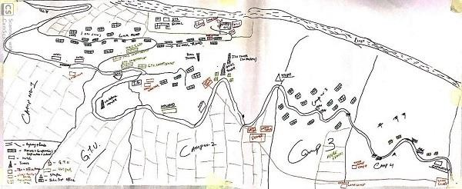

Tenzingang resource map

* + - The PNA in **Ravangla** Kunpheling settlement was completed over a period of five days. Following pre-PNA exercises and a transect walk through the settlement, three stakeholder groups were identified: women, business owners and youth. Each group was divided into camp-wise sub-groups, and participatory methods were followed to explore community strengths and aspirations. After prioritizing needs, each stakeholder group selected their highest-priority proposals using pair-wise ranking. In total 49 (19M / 30F) community members participated and generated a total of 16 community-based, group- based and individual proposals, including equipment for a cooperative society, non-

structural renovation of two community halls, equipment for a group of women vendors, and support for an existing dairy farm.

* + - In **Sonada** Tashiling settlement a PNA was conducted over a five day period. A similar process of pre-PNA exercises was conducted and three stakeholder groups were identified: women, business owners and youth. With PNAF facilitation, each stakeholder group used participatory tools to explore community strengths and aspirations, identify needs and prioritize activities using pair-wise ranking. In total 42 (18M / 24F) community members participated and generated a total of six community-based, group-based and individual proposals including non-structural renovation of a community hall, purchasing a Tibetan apron weaving machine, and setting up a community gym.

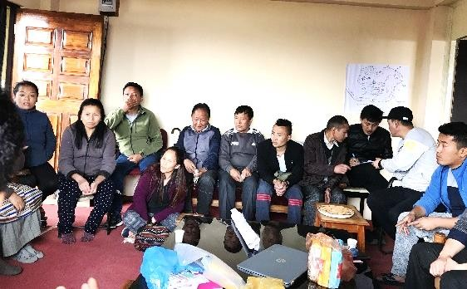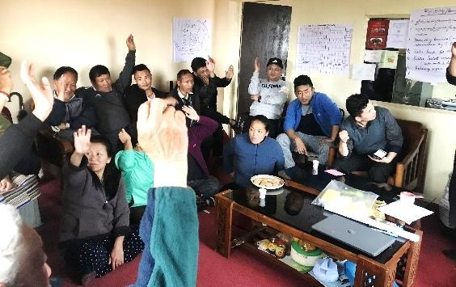

Pair-wise ranking exercise to prioritize community needs in Sonada

* + - In **Bomdila** a PNA was conducted over a five day period. Bomdila has six Tibetan cluster communities: Bomdila town, Tenga Birpur, Rupa Garcham, Dirang, Itanagar, and Tawang, each comprising of 10 to 48 households. 18 representatives from these communities were invited to Bomdila, where the approach and objectives of PNA were explained. They then divided into sub-groups to discuss community strengths and participate in PNA exercises. A total of 20 community-based and individual proposals were identified including support for a traditional metal working group, a tailoring center, and a noodle manufacturing unit.
    - In **Kalimpong** a PNA was conducted over a period of six days. Kalimpong has seven Tibetan cluster communities: Kalimpong town, Salugara, Jaigaon, Oodlabari, Pedong, Algarh, and Lava. Two separate PNAs were held, one for residents of Kalimpong and one for representatives of the other cluster communities. Kalimpong residents were further divided into three sub-groups. In total 41 community representatives participated in PNA exercises and generated a total of 14 community-based, group-based and individual proposals, including support for Tibetan language classes, improvement of a community hall, a water supply truck, and establishment of a travel agency.
    - In **Darjeeling** a PNA was conducted over a six day period. Darjeeling has ten Tibetan cluster communities: Darjeeling town, Ghoom, Mirik, Kurseong, Mile 3.6 and Takda, Lamahatta, Sukia and Pashu, Manibanza, Pokhribong, and the Tibetan Refugee Self-Help Center. Three separate PNAs were held, one for residents of Darjeeling, the second for

residents at the Tibetan Refugee Self-Help Center, and the third for representatives from other cluster communities. A total of 51 participants generated 49 community-based, group-based and individual proposals, including support for a group of women vendors, a Tibetan bakery, a Tibetan café, and a *tsampa* (roasted barley flour) business.

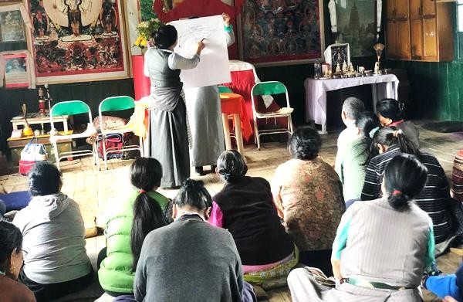

Darjeeling residents taking part in PNA meeting

* + - In **Gangtok** a PNA was conducted over a five day period. 78 participants members from several cluster communities were divided into three groups and generated a total of 29 community-based, group-based and individual proposals, including support for local community halls, musical instruments for Tibetan culture classes, and establishment of an auto repair enterprise.
    - Following submission of PNA result sheets and reports from each settlement senior DOH officials began visiting settlements to review proposed activities on the basis of practicability, viability, beneficiary inclusiveness and sustainability. Final selection of projects by the central ISDP committee is schedule in the next quarter, after which proposals will be submitted for USAID approval prior to implementation.
    - In the past quarter implementation also continued of several **community development activities identified and approved in 2017-18 for TSRR support**, as follows:

In Mainpat settlement in Chhattisgarh, work continued to establish a **buckwheat noodle production facility**. A buckwheat shelling machine was installed, and non- construction renovation work on the production hall was completed.

In Dekyiling settlement in Dehradun, new **textile weaving machinery** was assembled and a trainer began providing weaving training to two handicrafts center staff; new mechanized looms are expected to start producing textiles by the end of the next quarter.

In Bandhara settlement in Maharashtra, implementation began of two community priorities identified in 2018. Sewing machines and over-lock machines were delivered and orders for cloth were placed for a **new tailoring enterprise.** Managed by a group of eight

women, the Shidhe Tailoring Center is expected to open in the next quarter following delivery of remaining machinery. Work also began on nonstructural cosmetic renovation of the **Bandhara community center**.

In Chandragiri settlement in Odisha work began on three community priorities identified in 2018. Orders were placed for **maize peeling, shelling, and dehusking equipment** and work began to install a **borewell pump** to irrigate existing cashew fields. An expert from eQuiera, an agriculture consultancy firm based in Bhubaneshwar, conducted an initial survey to develop an **ecotourism development plan** for unused land near the settlement with tourism potential. The plan is expected to include designs for agriculture, horticulture, and floriculture cultivation, a dairy farm, vermicompost, visitor cottages, and a small building for seasonal businesses.

In Mundgod settlement in Karnataka implementation continued of two community priorities identified in 2018, a **tailoring enterprise** and a **carpentry enterprise**. Installation of carpentry machinery and electric wiring began, and preparations continued to organize training for carpentry apprentices. A third community priority identified in 2018, a prayer flag enterprise, was withdrawn by stakeholders, while a fourth, development of a new **petrol pump** enterprise, was indefinitely postponed due to lack of approval from USAID.

In Bylakuppe settlement in Karnataka implementation was completed of two community priorities identified in FY18. **Irrigation and water supply systems** in camps #1 and #6 were improved by installing submersible pumps and pipes that will benefit 14 farming families in these camps. Work also began to establish a **tailoring center** in the settlement. Sewing machines and furniture were ordered, and floor and roof repairs at the center were completed through stakeholder cost sharing. Cosmetic renovation of the Bylakuppe Milk Producer Cooperative Society’s office was also completed. New wall painting and coverings were applied and electrical wire and broken windows and doors were replaced.

In Hunsur settlement in Karnataka implementation continued of three community priorities identified in 2018: a **bakery enterprise**, a **tailoring enterprise** and a **noodle production enterprise**. With the help of TSRR funded baking equipment and supplies, the Ama bakery group began baking and is now selling more than 400 doughnut and flat bread items per day. In the future they hope to expand to supply local monasteries and Tibetan and Indian shops. The Hunsur tailoring enterprise received twelve sewing machines, an interlock machine, cloth material, furniture, and supplies including scales, scissors, threads, needles, and measuring tapes. An enterprise manager was hired to oversee the enterprise and an experienced trainer began training twelve apprentices in different styles of stitching traditional Tibetan clothes. The Hunsur noodle enterprise received a kneading machine, noodle making machine, and motor pump. An experienced noodle maker was invited to provide guidance, and test production began of two varieties of packaged dry noodles.

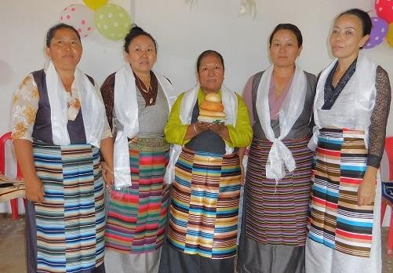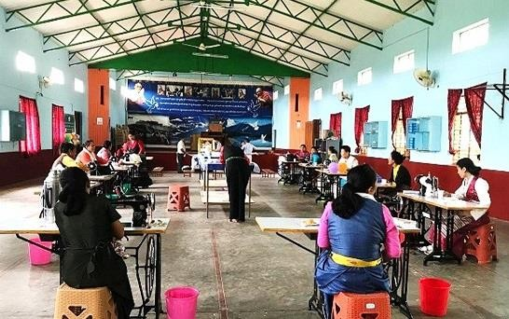

Ama bakery owners (left) and tailoring enterprise workers (right) in Hunsur

# KRA 8: WOMEN EMPOWERMENT

This cross-cutting component aims to ensure gender perspectives are incorporated in the design, implementation and monitoring of program activities, ensure women and men participate in and benefit equally from USAID support, and address key issues facing Tibetan women and girls. With the inception of TSRR a diagnostic assessment was conducted to provide evidence-based recommendations to inform phase II planning, and a road map was developed that outlines a multi-year strategy for FY19-FY21. While the assessment was being conducted in FY17-18, TSRR supported gender sensitization workshops, women’s leadership training, and pilot menstrual health and hygiene activities. Phase II of this program component began in FY19 with support for a new strategy to prevent and respond to sexual and gender-based violence (SGBV), gender sensitization and women leadership trainings, menstrual health and hygiene awareness, and capacity building of CTA’s Women Empowerment Desk (WED).

# Activity progress:

* + - WED conducted four **gender sensitization workshops** at Mundgod Tibetan settlement and the Dalai Lama Institute for Higher Education, Bangalore. A total of 119 participants including settlement residents, secondary school students, and college students attended workshops led by WED staff. The one-day workshops covered topics including gender roles and stereotypes, differences between gender and sex, the power of patriarchy and gender-based violence.
    - WED organized a second two-day stakeholder meeting to review its **draft SGBV guidelines**. Representatives from three NGOs and one school system divided into groups to discuss how redressal mechanisms and internal SGBV committees could be best established in different institutions and community settings. The meeting was facilitated by a gender specialist from Martha Farrell Foundation.
    - WED organized a **training of trainers** (TOT) on GBV at Martha Farrell Foundation (MFF) in Delhi. 17 trainees participated in the five-day training. Led by MFF trainers the workshop

focused on topics including gender stereotypes, gender role divisions and power relations, gender and work, GBV, and trauma counseling. The workshop also included sessions on Indian laws for the safety of women and children such as POSCO and Juvenile Justice Act of India. In addition, trainees also learned different methods and techniques to effectively facilitate GBV workshops.

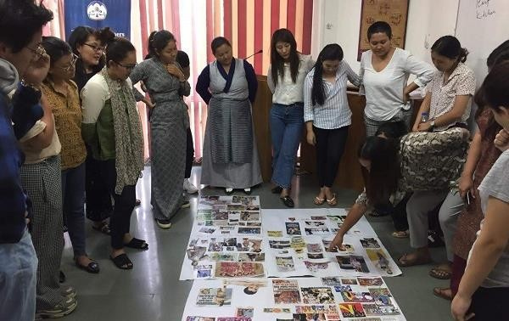

Gender-Based Violence training of trainers in Delhi

# KRA 9: INSTITUTIONAL CAPACITY DEVELOPMENT

Institutional capacity development focuses on the program’s key implementing partner, the Central Tibetan Administration (CTA), the primary institution responsible for ensuring self- reliance and resilience of Tibetan communities in South Asia. In 2017-18 organizational development assessments (ODA) were conducted to assess capacity strengthening needs of selected CTA units in Dharamshala, as well as a cultural institute in India and an NGO partner in Nepal. Led by professional facilitators, ODAs produced organizational development (OD) road maps and plans encompassing systems improvement, staff training and professional development, and other capacity development priorities. In FY19 ODAs will be conducted for two additional CTA units.

# Activity progress:

* + - The CTA Department of Information and International Relations (DIIR) continued working with a noted international lawyer and long-time advisor to the department to conduct its **organizational development assessment**. After completing assessments of the Offices of Tibet (OOT), he will provide policy recommendations and strategic plans for all DIIR sections including advocacy, campaigns, international relations, administration, and human resources. DIIR is then expected to begin implementing an OD road map and

action plan encompassing systems improvement, staff training and professional development, and other capacity development priorities identified in the ODA process.

* + - 38 staff from CTA’s major departments of home, education, health, finance and information and international relations continued a six-month long capacity building and **on-the-job training on core competency and project management**. The consulting firm Intellecap provided five training sessions on communications, public speaking and presentation making, the pyramid principle, fundraising and mapping donor opportunities, and monitoring and evaluation. A baseline assessment was conducted to understand trainees’ functional roles, responsibilities and skill sets. The training is expected to improve utilization of human resources and funds, synergies across departments, data tracking and reporting, efficiencies, and staff retention.

# KRA 10: LEADERSHIP DEVELOPMENT

The CTA employs over 500 administrative and technical staff, only a handful of whom had received formal training in leadership or public administration prior to TSRR. In FY17 TSRR began supporting a multi-year strategy of staff leadership development that focuses on senior and mid- level officials with managerial and administrative responsibility; junior CTA and settlement office staff with potential to become future leaders; recent graduates aspiring to enter public service; and students interested in public service and public leadership. Short and long-term training courses, workshops, and graduate study opportunities are provided for these groups, creating an interlinked sequence of leadership and professional development training for CTA staff at each stage of service. TSRR also supports Tibet Corps, a program which provides Tibetan professionals, students and CTA retirees an opportunity to serve the CTA through voluntary service. In Nepal, the program is supporting leadership development training for women community leaders, students and staff of settlement offices and partner organizations.

# Activity progress:

* + - Four recipients of **public service scholarships** (PSS) completed their master degree programs at the Jindal School of Government and Public Policy (JSGP). Designed for Tibetan college graduates who commit to at least five years of public service with the CTA, PSS are intended to increase the number of CTA job applicants with advanced training in public policy and government.
    - 28 aspiring CTA civil servants, most of whom are recent graduates from college and graduate school, completed the second and final phase of a ten-month **pre-service public administration training** program at Sarah College for Higher Tibetan Studies near Dharamshala. The three-month-long final phase of the training focused on CTA administrative rules and regulations, the Tibetan Charter and democratic structures, auditing and budgeting, and leadership and communication. A graduation ceremony was held and reputed Tibetan scholar Tashi Tsering Josey was invited to give the keynote

address. Other senior CTA staff were also present at the ceremony. Upon successful completion trainees are expected to take the CTA civil service entrance exam, for which the course is designed to prepare them.

* + - 21 mid-senior CTA staff at the ranks of Deputy Secretary, Under Secretary and Section Officer attended a ten-day **leadership and management training** at the Indian Institute of Public Administration (IIPA) in Delhi. The training included theoretical and practical sessions on building team synergy, leading organizational transformation, change and time management, emotional intelligence, effective communication, leadership and decision making, public policy and administration, ethics and values in governance, and conflict management.
    - 35 Tibetan professionals provided voluntary services at various CTA departments and offices in Dharamshala as well as in hospitals and one school in seven Tibetan settlements as part of the **Tibet Corps** program. Tibet Corps offers Tibetan professionals, university students, and retirees an opportunity to serve the CTA through voluntary service, and aims to inspire volunteers to strengthen the Tibetan community and its institutions beyond their term of service. TSRR is supporting living stipends, accommodation, and travel expenses for all 35 volunteers.
    - In Nepal, 87 grade 10 and 12 students from Namgyal High School and Srongtsen School in Kathmandu and SOS School in Pokhara participated in two **student leadership trainings**. The 2-day long trainings were organized by the local NGO Himalayan Society for Youth and Women Empowerment (HSYWE) and led by trainers from the National Research and Development Foundation. Trainings focused on developing leadership qualities, effective communication skills, building positive habits, time management, ethical leadership, emotional intelligence, and career options.
    - 14 women working in Tibetan settlement offices and NGOs took part in a **women’s leadership training** in Pokhara. The women were gender focal persons, social mobilizers, health workers and members of the Tibetan Women’s Association. Organized by HSYWE, the training focused on communication and facilitation skills and conflict resolution tools. A second women’s leadership training will be held in Kathmandu in the next quarter.
    - 21 Tibetan settlement office and NGO staff attended a 2-day **leadership training** in Dhulikhel on the outskirts of Kathmandu. Five resource persons from various organizations led the training. The content of the training was designed by HSYWE based on capacity building areas and support identified by the participants. Topics included project management, financial management, monitoring and evaluation, and Microsoft project software. A 4-day follow up training was conducted in Kathmandu for 13 participants from the first training. The training provided additional guidance on project management and financial management and included a session on building workplace communication skills and report writing.

# KRA 11: CULTURAL INSTITUTION AND RESILIENCE STRENGTHENING

* 1. **Tibetan Performing Arts Revitalization**

Founded by His Holiness the Dalai Lama in 1959, the Tibetan Institute of Performing Arts (TIPA) in Dharamshala is the most prominent institution in exile preserving Tibetan classical performing arts, folk song and dance traditions, and traditional opera. The institute currently employs 50 performing artists, composers, choreographers, and production staff, and stages an average of 50-60 performances per year in India and abroad. TIPA is widely considered a critical pillar of Tibetan cultural preservation due to its stewardship of centuries-old, highly developed art forms and living traditions that have either disappeared or been diluted inside Tibet.

With the inception of TSRR a diagnostic assessment of TIPA was conducted to provide evidence- based recommendations to inform phase II planning. While the assessment was being conducted in FY17-18, TSRR supported TIPA performance skills training, cultural events and facility improvements. Phase II of this program component begins in FY19 Q1. As part of the assessment a road map was developed that outlines a multi-year strategy for TIPA, with a timetable and notional targets for FY19-FY21. Key assessment recommendations included developing a standardized curriculum and syllabus for student-artists who undergo five years of intensive training at the institute; revamping the leadership including bringing on board a creative director; creating avenues for involvement in the institute of former TIPA artists; providing more educational opportunities for artists; and producing a detailed road map focusing on institutional capacity strengthening, financial stability and a branding strategy for TIPA.

# Activity progress:

* + - TIPA’s curriculum committee continued work on a standardized **performing arts course curriculum**. A draft of the second year course book was completed and submitted to a committee of experts for review. The committee will help finalize the first and second year course books in the next quarter, after which a workshop will be provided to TIPA faculty members to introduce the course books. The new curriculum will have a nine-year course syllabus divided into three levels: the first level will require four years of study and practice for a trainee to become an intermediate performing artist; the second level will require three years of intermediary academic and performing arts studies for a trainee to become a senior artist; and the third level will require two years of advanced training for a senior artist to receive a master’s degree in performing arts.
    - 30 performing artist trainees continued receiving **pre-service training** at TIPA. In addition to regular classes, trainees took part in TIPA’s annual Yarkyi cultural dance competition. Fourth-year trainees attended opera classes with senior artists, third-year trainees learned basic opera arias of opera prelude performances, and second-year trainees learned verses of arias that are sung in the opera preludes. Trainees were also given opportunities to perform for guests and the public with senior artists.
    - Eleven new performing artist trainees were recruited for **pre-service training** following auditions in Bylakuppe settlement and Dharamshala. The new trainees began attending regular Tibetan and English language classes along with classes on ceremonial songs, flute notation and marching band songs.
    - 29 pre-service trainees and seven senior artists received training in the unique traditional art of playing the ***Toepa dranyen*** (Tibetan lute). An expert trainer was invited to conduct the training, which focused on the distinct tuning, strumming and hammering style that is specific to the Toe region of Tibet. Trainees also learned the musical and tactical notations of Toepa folk songs. At the completion of the 15-day training trainees gave group performances and received feedback from the trainer.

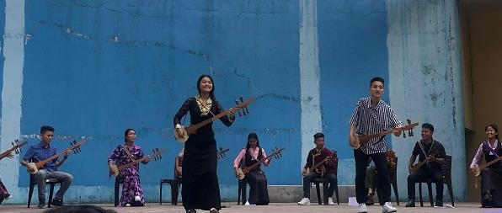

Group performance following *Toepa dranyen* training

* + - 31 performers from eleven regional opera associations took part in a two-week **opera performance training** held at TIPA. Five senior teachers at TIPA led the training which focused on opera drum notation, prelude performance dances, slow and fast paced operatic dance styles, opera arias, animal dance styles, and the black hat *cham* dance. TIPA’s artistic director conducted a session on the importance of the Tibetan opera tradition, and books on three classical opera performances – Sukyi Nyima, Drowa Sangmo and Pema Woebar – were distributed. The training was aimed at improving opera performance skills of participants so they can later impart their skills to opera troupe members in their settlements.

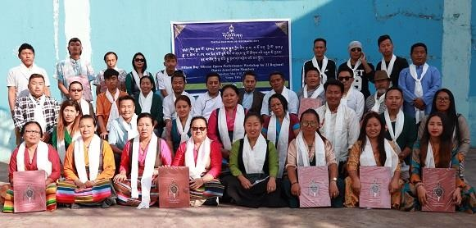

Opera performance training for regional opera troupe members

* + - Five performance costume tailors at TIPA began taking part in a multi-session training **workshop for tailors** led by the Dharamshala based master tailor *namsa chenmo*. The training focused on measurement tools and their Tibetan nomenclature, standard measurements and designs of *chupa* dresses for men and women from different Tibetan provinces, and cutting and stitching techniques for women’s c*hupa*. Choosing and matching of *chupa* materials was also discussed. The final two sessions of the training will be conducted in the next quarter.

# Tibet Museum

In 2017 the Central Tibetan Administration began establishing the Tibet National Museum, a new cultural institution located in Dharamshala expected to contribute to the objective of increasing cultural vitality and resilience of Tibetan communities in exile. In 2017-18 TSRR provided support to hire a team of consultants to advise on museum planning and curation, print publications and prepare exhibitions. In FY19-20 the final phase of support is being provided for equipment installation and other preparation work in advance of the museum opening, currently scheduled for early 2020.

# Activity progress:

* + - Preparations to open the new Tibet Museum continued. Museum’s head curator Dr. Emma Martin held online meetings with staff and set deadlines for completion of sourcing exhibition contents for ‘Invasion,’ ‘Introduction,’ ‘History’, and ‘Environment’ sections. Museum staff travelled to Delhi with two exhibition designers and met staff of the production company Design Habit. The team visited museums in Delhi where Design Habit has worked to review and understand their artistic work and approach. Exhibition designers and two Design Habit experts then visited Dharamshala to view the new museum site. They discussed interior design plans, display panel materials, products and colors.
    - Museum staff visited Bylakuppe, Hunsur and Kollegal Tibetan settlements in south India to solicit **artifacts** related to Tibet history and culture. Another team led by the museum director visited four settlements in Nepal to source artifacts and old photos. Artifact donations included property ownership papers issued by Tibetan authorities before China’s invasion and Tibetan military uniforms. In Nepal, museum staff met with the content developer of the ‘Resistance and Resilience’ section and received updates. The team also interviewed a popular Tibetan traditional and contemporary singer in Kathmandu to document the emergence of contemporary Tibetan music in exile for the ‘Hope and Success’ section of the new museum.
    - Tibet Museum’s **museology studies scholarship** recipient continued his two-year master’s degree in museology at the National Museum Institute in Delhi. The scholarship recipient has signed a contract to work at the museum for at least three years upon completion of the course.

# Tibetan Arts and Culture Small Grants Fund

The Tibetan Arts and Culture Fund (TACF) was established under TSRR to strengthen Tibetan cultural resilience. Administered by the CTA Department of Religion and Culture, TACF awards small grants of up to $5,000 to individual artists and small cultural organizations.

# Activity progress:

* + - All recipients of small grants awarded in FY17 and seven recipients of small grants awarded in FY18 completed their projects, while the remaining five continued to make steady progress. TACF grants are awarded for either specific projects or general support to individuals who are full-time practitioners of one or more aspects of Tibetan culture preservation and promotion. recipients include the Norbulingka Institute, Tibetan Karma Gardi Traditional Art of Thangka Painting, Milarepa Preservation Association, Shalu Monastery, Dangla Riwo Association, two Tibetan culture associations, and five individual Tibetan artists and researchers. Progress made by TACF awardees in the past quarter was as follows:
      * Production and Preservation of Clay Statues: Tibetan artist Rangdon produced three clay statues of the Lord Buddha and Avalokiteshvara, the bodhisattva of compassion.
      * Preservation of Tibetan Karma Gardi Traditional Art of Painting: Seven new recruits completing their training in the distinctive Karma Gardi painting and drawing style.
      * Milarepa Preservation Association ordered ritual masks (*cham bak*) from skilled artisans at Tso Pema, Himachal Pradesh.
      * Short course on the art of sand mandala making: Monks from Shalu Monastery completed their training from a learned teacher from Gyuto Tantric Monastery.
      * Documentary film on Tibetan Buddhist Death Rituals: Filmmaker Sonam Tseten sorted primary footage to assess whether additional shoots are necessary, and continued work on translating subtitles, editing, and researching characters.
      * Norbulingka Institute completed printing the Tibetan Encyclopedia, Volumes 12- 16.
      * Historian Tsewang Topla completed and published a book on Tibetan history focusing on the historiography, literature and research methodology of Tibetan history.
      * The scholar Kunchok completed editing and preliminary proofreading of Volume I of Je Tsongkhapa’s poetry and commentaries, and also completed preliminary proofreading of Volume II, a collection of research and analysis papers.
      * The scholar Nyenthar completed translating documents relating to the 2,200- year-old Tunhuang manuscripts.
      * Gangjong Doeghar Association: 27 children completed their training in Tibetan dance and song, five artists completed their training in recording skills, and studio equipment was purchased.
      * Dangla Riwo Association completed a publication of rare ancient texts of teachings, rituals, guides to sacred places, and dharma songs.
    - In the past quarter CTA’s DoRC made an announcement for the third TACF. A total of 25 applications were received, and the process of sorting and reviewing began. Applicant interviews and final selection will be completed in the next quarter.

# Himalayan Buddhist Library and Cultural Center

The Himalayan Buddhist Library and Cultural Center (HBLCC) was established in 2017 with the mission of preserving Tibetan-Himalayan cultural heritage and strengthening cultural ties between Tibetan and Himalayan communities in Nepal. In FY17, an organizational assessment was conducted to inform planning for phase II of TSRR. Key assessment recommendations were to engage youth from both Tibetan and Himalayan communities; promote cooperation with Buddhist institutions and organizations; develop a strong digital outreach program; form dharma and culture clubs for youth and children; conduct shared events with Himalayan communities; develop links to international researchers; and serve as a knowledge sharing network. In FY19 TSRR is providing support for a youth cultural awareness campaign, adult literacy program, Trans- Himalayan studies seminars, Buddhist teaching, meditation and yoga events, museum development and permanent cultural exhibitions, and translation of a book authored by His Holiness the Dalai Lama into Nepalese language.

# Activity progress:

* HBLCC continued organizing **adult literacy classes** in Pokhara and Walung, and began organizing new literacy classes in the remote border region of Lapchi, where there are large Tibetan-speaking Himalayan communities. Basic Tibetan reading and

communication skills are taught to enable participants to read and recite Tibetan Buddhist texts.

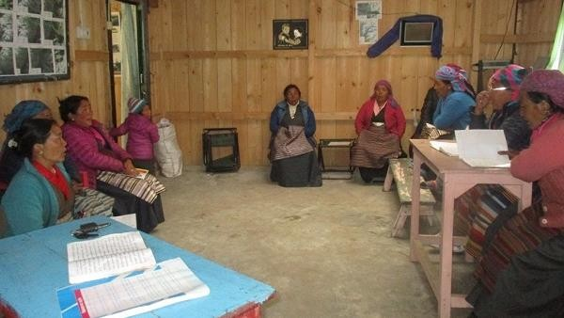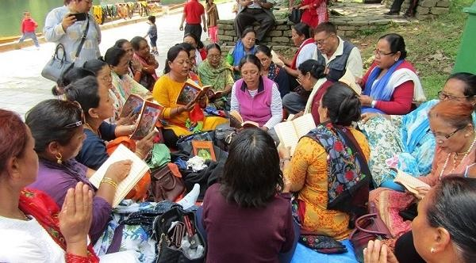

Adult literacy classes in Walung (left) and Pokhara (right)

* HBLCC organized a day-long **trans-Himalayan studies seminar** in Kathmandu to facilitate linkages among researchers and act as a knowledge-sharing hub. 14 scholars attended from different institutions in Kathmandu including Rangjung Yeshi Institute, International Buddhist Academy, and regional monasteries. The theme of the seminar was the *Rime* (nonsectarian) approach of Tibetan Buddhism. Five young people attended the seminar as external observers.
* HBLCC organized a **youth meeting** for Tibetan Homes Foundation School alumni in Kathmandu. Youth club meetings aim to encourage youth from Himalayan and Tibetan communities to share and promote their culture.
* A **documentary tour** continued with screenings of ‘Practices of a Bodhisattva’ and live broadcast of a long-life prayer ceremony for His Holiness the Dalai Lama held in Dharamshala. 49 elder residents of Tsering Elders Home and Jawalakhel Elders Home attended the screenings. The documentary tour will continue in the next quarter with screenings at different locations.
* The **History and Religion Gallery** at HBLCC was inaugurated in the past quarter. Around 60 guests including settlement officers, school principals, students, and staff of partner organizations attended the inauguration. The gallery houses models representing three provinces of Tibet, replicas of the Potala Palace and Yumbu Lhakhang, a model stupa, a medicine mandala, and an altar with statues and thangkas. An audio-visual station plays videos of Tibetan and Himalayan cultural events.

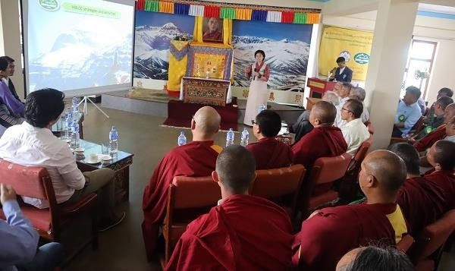

Inauguration of HBLCC history and religion gallery

# MONITORING, EVALUATION, AND LEARNING

* + Over the past quarter the TSRR MEL team carried out continuous monitoring of program activities through field visits, focus group discussions, key informant interviews, phone surveys, online surveys, and partner meetings with implementing partners. Activity reports, progress updates, signed participant lists and other information were gathered, and lessons learned and suggestions for improvement were recorded and shared with partners. Work also continued on the baseline survey report, which will be completed in the next quarter.
  + A delegation of Kali Farahmand, staff at the Committee on Appropriations, Dorothy J. Rayburn, USAID Congressional Liaison, and Xerses Sidwai and Thomas Kress from USAID India visited Dharamshala. The delegation met with Sikyong Lobsang Sangay and visited The Tibet Fund’s field office. They met with Department of Health staff and visited a few project sites including a school and skills training center.

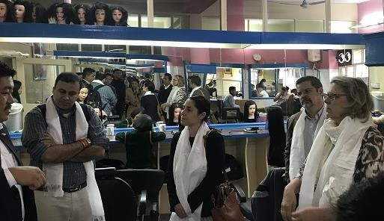

The delegation visiting Dharamshala Tibetan Career Center

* + USAID India OSSI Director Thomas Kress and Program Management Specialist Balaka Dey visited Tibetan settlements and TSRR project sites in Nepal, where they interacted with NGO implementing partners Snow Lion Foundation, Lodrik Welfare Fund and Himalayan Society for Youth and Women’s Empowerment and met with settlement officers. The delegation visited several USAID funded entrepreneurship development beneficiaries in Kathmandu and Pokhara, including a pre-school, cake shop, and noodle business, who described how TSRR had supported the growth of their businesses. In Pokhara, the delegation observed a training for Community Managed Revolving Fund (CMRF) social mobilizers, and met CMRF loan recipients to understand loan utilization. In Jampaling settlement, the agricultural extension officer guided delegates around a USAID-supported banana plantation and vegetable nursery, and farmer beneficiaries shared their successes and challenges. The delegation also visited Atisha Primary School in Jawalakhel where they observed EGR reading corners and interacted with students and teachers. This was USAID India’s first visit to Nepal.
  + USAID India Program Specialists Balaka Dey and Chandan Samal visited Dharamshala to conduct a data quality assessment (DQA) of the TSRR program. The DQA was aimed at ensuring that all performance data reported to USAID meet the data quality standards of ADS 201 and are valid, complete, accurate, and consistent with management needs. TTF’s chief of party and MEL staff gave a detailed presentation on the overall TSRR program structure and monitoring, evaluation, and reporting procedures and practices. Staff explained data collection, verification, and management processes, and gave demonstrations of the program information database and data storage systems.

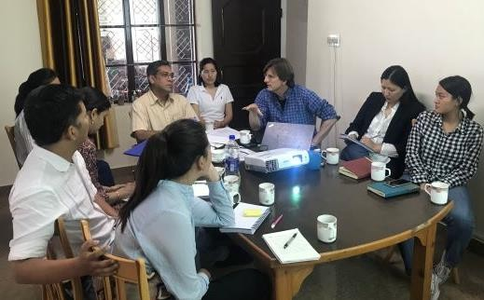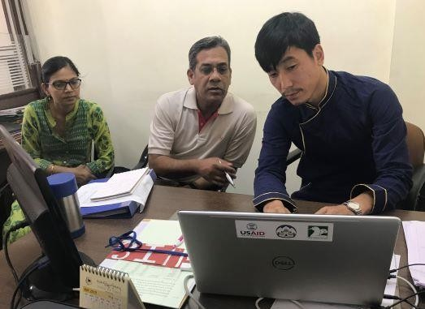

USAID DQA team at TTF field office (left), and conducting a cross check with partner staff (right)

USAID’s DQA team reviewed internal systems for data collection and analysis, and assessed the flow of information for eleven TSRR program indicators. The team visited CTA partner offices including the Departments of Finance, Home, and Health as well as the CTA Public Service Commission and SARD M&E section to assess the quality of partner data management and reporting systems. Considerable time was spent at each office to understand how data flows from implementing partners to TTF to USAID, and cross checks were conducted of reported numbers from past reports against data at partner offices.

The team also conducted spot checks at the Tibetan Institute of Performing Arts, the beauty salon of a former trainee at Dharamshala Tibetan Career Center (DTCC), and street vendor stalls of loan beneficiaries to verify actual delivery of services.

In a debriefing session with TTF’s MEL staff, the DQA team shared their initial findings and recommendations to strengthen data management systems, improve data quality, and increase the focus of monitoring from outputs to outcomes. They encouraged the team to further strengthen partner MEL capacity as well as conduct more field visits and inform management of lessons learned and recommendations.

* + TTF’s Education Coordinator and SARD’s M&E Officer visited eleven schools in Dharamshala, Bir, and the Dehradun area to monitor EICT, EGR and TPD activities. They observed classrooms and libraries, held focus group discussions with teachers, and conducted rapid surveys to collect teacher suggestions on improving EGR and TPD programs. A monitoring report on findings and recommendations was submitted to the Department of Education, and a lessons learned presentation was scheduled in the next quarter to present key visit findings and recommendations.
  + TTF and SARD staff conducted a joint monitoring visit to the Dharamshala Tibetan Career Center, where they held focus group discussions with hairdressing and computer trainees, and survey interviews with DTCC administrators and trainers. Needs were identified for more effective career awareness programs and improved quality and variety of training courses.

**Annex 1: Summary Performance Data**

|  |  |  |  |  |  |  |
| --- | --- | --- | --- | --- | --- | --- |
| Standard Indicator | Baseline | FY 19 | Q1 | Q2 | Q3 | FY 19 |
| Target | Actual | Actual | Actual | Total |
| EG.4.2-1 Total number of clients benefiting from financial services provided through  USG-assisted financial intermediaries, including non-financial institutions or actors | 1,982 | 2,360 | 1,470  804M  / 666F | 179  New 99M/80F  Cont.  208M/148F | 65  New 34M/31F  Cont.  215M/150F | 1,714  937M  / 777F |
| EG.6-1 Number of individuals with new or better employment following completion of USG-assisted workforce development programs | 79 | 75 | 15  7M  / 8F | 10  6M  / 4F | 7  6M  / 1F | 32  19M  / 13F |
| EG.6-3 Number of individuals who complete USG- assisted workforce development programs | 524 | 305 | 89  55M  / 34F | 34  New 23M/11F  Cont.  18M/9F | 47  New 29M/18F  Cont.  0M/2F | 170  107M  / 63F |
| EG.3.2-1 Number of individuals who have received USG-supported short-term agricultural sector productivity or food security training | 241 | 925 | 0 | 117  New 76M  /  41F | 59  New 33M./26F  Cont.  5M/6F | 176  109M  / 67F |
| EG.3.2-17 Number of farmers and others who have applied improved technologies or management practices with USG assistance | 200 | 840 | 199  137M  / 62F | Cont. 137M  / 62F | 86  New 57M/29F  Cont.  131M/59F | 285  194M  / 91F |
| EG 3.2-18 Number of hectares of land under improved technologies or management practices  with USG assistance | 270 | 1,540 | 272 | 272 Cont. | 374  102 New  /  272 Cont. | 374 |
| ES.1-1 Percent of learners who demonstrate reading fluency and comprehension of grade level text  at the end of grade 2 with USG assistance | 26% (I) | 70% (I) | Pending (Annual Indicator) | Pending (Annual Indicator) | Pending (Annual Indicator) | Pending (Annual Indicator) |
| ES.1-5 Number of learners reached in reading programs at the primary level with USG assistance | 5,238 | 6,033 | 4,957  2,623M  / 2,334F | 4,957  Cont. 2,623M  / 2,334F | 2,374  New 391M/361F  Cont.  835M/787F | 5,709  3,014M  / 2,695F |
| ES.1-6 Number of primary or secondary educators who complete professional development activities with USG assistance | 1,507 | 1,233 | 63  21M  / 42F | 49  Cont. 17M  / 32F | 288  New 114M/174F  Cont. 18M/34F | 351  135M  / 216F |
| ES.2-2 Number of individuals attending tertiary education institutions with USG scholarship or financial assistance | 382 | 332 | 258  111M  / 147F | 1  New 0M/1F  Cont.  111M/147F | 9  New 5M/4F  Cont.  111M/148F | 268  116M  / 152F |